|  |
| --- |
| http://www.ccsu.edu/_resources/img/nav/logo.png Central Connecticut State University Department of Engineering Mechanical Engineering Program |

ME 498 Senior Design Project Report

**K-MAX Helicopter Vibration Analysis & Damping**

**Final Report**

Massimo De Santis

Devan Ford

Alexander Kokkoros

Sean Lamb

Advisor(s): Dr. Wei

December 15, 2017

This report is written in partial fulfillment of the requirements in ME 498 – Senior Design Project. The contents represent the opinion of the authors and not the Department of Engineering

Abstract

Vibration is an important factor when building any mechanical system especially a helicopter as it not only affects performance, but can be hazardous by causing premature wear and failures within the helicopter. This paper looks at the vibration experienced in a model K-MAX helicopter built by Central Connecticut State University. The K-MAX was built by multiple groups of students at CCSU who focused on creating different parts of the helicopter like the blades and gears. An issue that had not been addressed was the excessive amount of vibration that occurred within the helicopter and the stand it was tested on. Using a finite element model of the helicopter the vibration was examined and critical points of vibration were located. From this information a mass damping system was developed in an attempt to diminish the amount of vibration experienced within the model K-MAX. A test stand, which would isolated the vibration of the model helicopter, was also designed and manufactured in order to accurately perform tests. These tests were done on the model helicopter using an accelerometer to get specific frequencies of vibration in the helicopter and at different blade pitch angles and RPMs. Using MATLAB, the information from the accelerometer was interpreted into data that could be used to compare the vibrational characteristics between the different tests. Statistical analysis in MINITAB was performed to see which vibrational damping methods used lessened the vibration experienced by the helicopter. As the report will show the pitch angles that caused the most amounts of vibration were able to be identified. The new test stand had the greatest impact on damping the vibration that was occurring during the testing of the K-MAX. The mass damping system was unable to produce a statistical difference in the amount of vibration. Overall the vibration within the K-MAX was able to be reduced by testing it on a new test stand that was able to isolate much of the vibration being generated.

## Table of Contents

Contents

Table of Contents 3

Tables and Figures 5

Nomenclature 7

Acknowledgment 8

I. Introduction 9

II. Statement of Work 13

A. Problem Definition 13

B. Engineering Process 13

C. Design Constraints 13

D. Alternative design ideas and methods 14

III. Results 18

A. Selection of best design idea 18

B. Engineering analysis of solution 19

C. Cost analysis of design 21

D. Engineering Drawing or Parametric Models 23

E. Project Deliverables 24

1. Finite Element Analysis 24

2. MATLAB Analysis 25

3. Manufacturing Test Stand 26

4. Mass Damping System 27

5. RMS and Statistical Analysis 28

6. Test Stand Logarithmic Decrements 33

7. Vibration Characteristics 37

IV. Discussion 43

A. Engineering Standards 43

B. Impact Statement 43

C. Future Work 43

V. Conclusion/Summary 45

Bibliography 46

Appendix 48

## 

## Tables and Figures

Figure 1: Final Test Setup of K-MAX on Vibration Isolating Test Stand 12

Figure 2: Tasks and Schedule of Project 15

Figure 3: Gantt Chart of First Semester's Work 16

Figure 4: Gantt Chart of Second Semester's Work 17

Figure 5: Diagram of Wave Characteristics 19

Figure 6: Diagram of Logarithmic Decrements 20

Figure 7: Diagram of Half Power Bandwidth Method 21

Figure 8: CAD Drawing of Initial Test Stand Design 23

Figure 9: CAD Drawing of Isometric and Side View of Final Test Stand Design 23

Figure 10: Modal Analysis of Model K-MAX Helicopter Created using Autodesk Inventor 24

Figure 11: MATLAB Code Used to Interpret Accelerometer Data 26

Figure 12: Test Setup with Gel Masses Placed on K-MAX 27

Figure 13: Graph of RPM vs RMS for Tests Run at Different Pitch Angles 28

Figure 14: Graph of RPM vs RMS for Tests With and Without the Gel Masses 29

Figure 15: Graph of RPM vs RMS for Tests Run With and Without the Vibration Isolating Test Stand 29

Figure 16: Main Effects Plot for Different Variables Used During Testing 30

Figure 17: Interval Plot of RMS at Different Pitch Angles 31

Figure 18: Interval Plot of RMS With and Without the Gel Masses and Vibration Isolating Stand 32

Figure 19: Suspending the Test Stand 34

Figure 20: Mounting of Accelerometer 34

Figure 21: Waveform Impulse of Applying Force to Stand 35

Figure 22: Filtered Waveform Impulse of Applying Force to Test Stand 36

Figure 23: Sample of RPM Curve Found While Testing K-MAX at a Pitch Angle of 14 Degrees 37

Figure 24: Corresponding Spectrogram To Figure 22s RPM Curve 38

Figure 25: 15 Hz Peak 39

Figure 26: 153.8 Hz Peak 39

Figure 27: 337.3 Hz Peak 40

Figure 28: 461.3 Hz Peak 40

Figure 29: 615.3 Hz Peak 41

Figure 30: 922.8 Hz Peak 41

Figure 31: 2614 Hz Peak 42

Table 1: Cost Analysis 22

Table 2: Probability Values of Different Test Variables 32

Table 3: Probability Value of Different Pitch Angles Used During Testing 33

## Nomenclature

pp:natural frequency of pendulum dampener

*n*: tuning coefficient

Ω: rotational speed of rotor

ω: excitation frequency of the blade

δ: logarithmic decrement

ξ: damping ratio

P: period

ωd: damped frequency

ωn: natural frequency

B1: first peak of waveform graph

B2: last peak of waveform graph

n: number of cycles

k: spring constant

c: damping coefficient

Q: quality factor

RMS: root mean squared

RPM: rotations per minute

CCSU: Central Connecticut State University

## Acknowledgment

We would express gratitude to our advisor, Dr. Wei who helped to guide us through the duration of the project.

We would like to thank John Favre from Paradigm Precision, who assisted us in welding the vibration isolating test stand for the model K-MAX helicopter.

We also wish to thank the other groups working on the K-MAX, who assisted us in the testing of the helicopter.

Grateful appreciation is extended to the entire Mechanical Engineering Department at Central Connecticut State University, who aided us through our academic careers.

# Introduction

A helicopter is an aircraft that generates lift through a set of revolving blades operating in a rotary configuration. The K-MAX is designed such that two rotor assemblies that intermesh and are able to be utilized at the same time to generate lift for the helicopter. This gives the K-MAX an exceptionally high power-to-weight ratio and enables the craft to carry much larger loads than helicopters of comparable size. In addition to supplying more power, there is no resulting torque put on the body of the helicopter since each rotor is driven in the opposite direction. This eliminates the need for a tail rotor, an integral feature on the conventional single-rotor design.

A common challenge in helicopter design is how to handle the effect of mechanical vibration supplied by the rotating blades. The vibrations felt by a helicopter can be detrimental to hardware life and performance. Extensive vibrations can cause instrumentation malfunctions and can even break apart the frame of a helicopter when resonance is hit. Resonance refers to the largest possible response exhibited by the craft because of the applied oscillation. The effect of vibration on the helicopter becomes a much larger risk in the case of the K-MAX. Since the K-Max does not have a tail rotor to help stabilize it during flight, excessive vibration from the dual rotor system can make the helicopter inoperable. Given the array of adverse effects that vibrations have on helicopters, the damping of it is a major part of helicopter design.

One major way of damping the vibration in a helicopter is by utilizing alternative materials for various components. Vibration is common where there is space for parts to move and hit into one another. A simple solution to this is to add a damping material in-between these two parts that is elastic and can absorb the impact. In the case of the helicopter, a common area for vibration of this nature to happen is at bolted connection. Since most of the frame and parts of a helicopter are bolted, large amounts of vibration can stem from this. Rubber washers is frequently used between these connections to absorb much of the impact that is transferred between the sections of the frame. This reduction in impact will dampen the vibration in the connection and stops it from transferring to other parts of the helicopter. Materials like rubber that more effectively absorb the energy released during impacts can be used in other areas of the helicopter that have moving parts. For example, the engine of a helicopter has a great deal of vibration so rubber pads are typically used between the engine and where it is mounted to absorb some of that vibration. The same technique is also used between the rotors and the frame of the helicopter. Most of the vibration in a helicopter is transferred through or generated by the rotors, so measures must be taken to try and eliminate as much of the vibration generated by the rotors as possible, before it spreads to the rest of the helicopter.

On many helicopters such as the K-MAX helicopter, pendulum dampers are used on the blades to dampen the vibration that is generated by them. The pendulum damper is a type of tuned mass damper that is allowed to oscillate on the blade and create a force in opposition to the force creating the vibration. This opposing force dampens the amount of vibration that is transferred from the blades, through the rotors, to the body of the helicopter. Pendulum dampers can be very effective on helicopters, as the blades produce a considerable amount of the vibration in helicopters, but as with anything that flies weight is critical. Ideally, in terms of vibration, the pendulum would be heavy in order to generate a large enough force to counteract the forces, like lift and drag, which are being generated by the helicopter blades. However, the more weight added to a helicopter the greater the amount of lift is needed to be produced in order for the helicopter to fly. So a heavy pendulum is actually counterproductive as it causes the helicopter to have to increase the lift it generates which would mean an even larger pendulum would be needed to cancel out the vibration it creates. Since the weight of the pendulum must be low, it has to make large amplitude oscillations to counteract the force being produced by the blades. Large amplitude oscillations can be difficult to model due to the high speed of the helicopter blades and the non-linear circular motion they move. Though these pendulum absorbers efficiently reduce vibration, the design and manufacturing of them is equally as complicated.

Along with the blades, the rotor of a helicopter produces ample amounts of the vibration that is experienced in a helicopter. Vibration is transmitted from the blades and rotor down into the body of the helicopter. One way to lessen the amount of vibration that is transferred into the body is to put additional support on the rotor of the helicopter. The less the rotor vibrates, the less vibration is transmitted to the body of the helicopter. A support can be built around the shaft which makes it more difficult for the shaft to shake and collide with the frame of the helicopter. The rotor needs to be able to rotate in order to turn the blades, but along with that usually comes lateral movement which is unwanted. The better the support is at eliminating the undesirable movement of the rotor the greater the damping of the vibration will be. The support has to be high strength to stop movement in the shaft and with that comes added weight to the helicopter which is always adverse. Along with weight if the support is rigid, vibration will be able to just travel through it instead of the shaft to get to the body. To avoid this, instead of one solid piece, the frame of the support can be made from a high strength material and be insulated with lighter material that can absorb vibration, like the rubber or even types of foam. Just like with the washers a material like rubber would be able to absorb and thus dampen the vibration that could travel through the support. Currently, on the K-MAX’s frame around the rotor, there are small pieces of foam on the connections of the shaft to the body. This is already working to dampen the vibration though it only lessens the transfer of vibration to the body of the helicopter and does not help to eliminate any of that vibration.

Among the most common types of vibration, dampers are mass damping systems. A mass damping system is a mass, spring, and dampener that works to counteract the vibration experienced in a system much like the pendulum dampeners. The mass is connected to the spring so when the helicopter starts to vibrate in one direction the spring forces the mass to move in the opposite direction. This creates an opposing force within the helicopter that can offset the vibration it is experiencing. Ideally, the mass would move at the same amplitude and frequency which would cancel out the vibration completely. In reality, it is not feasible to match the amplitude, but as long as the frequency of the mass damping system is the same as the frequency of the vibration, a similar amplitude to that of the vibrations in the helicopter will produce damping. A major issue with a mass damping system is that mass needs to be added to the helicopter for this to work, which again adds unwanted weight to the helicopter. In most helicopters, the mass used in the mass damping system is from an existing part of the helicopter like the battery. Another issue is that if the mass damping system is not properly tuned and the frequency of the system is not the same as the vibration in the helicopter it can actually make the vibration in the helicopter worse. In order to use a mass damping system careful analysis of the helicopter needs to be taken to find its modal points. Modal points are the areas where the largest displacement will occur due to the vibration of the helicopter. These are the areas that the masses will be placed, as they will have the most effect in damping the vibration.

With the amount of components that make up a helicopter, there are a lot of moving pieces that can cause vibration. The larger parts pose more of a threat to the helicopter since they have more mass. These heavy parts can act as an improperly tuned mass damping system, where the parts vibrate at a different frequency than that of the helicopter, making the vibration much worse. To avoid this the parts of the helicopter prone to vibration are mounted inside of it. By mounting things like the engine and the battery to the helicopter their effect on vibration can be lessened. Vibration isolators are often used to mount these parts. A vibration isolator is made of a material that is able to elastically deform at a range of forces that the part would create when it vibrates. When a part like the engine starts to vibrate, it produces a force that travels into the vibration isolator it is mounted on. The vibration isolator deforms, but since it is not a strong enough force to make the isolator permanently deform it compresses and goes back to its original shape. It is able to go back to its original shape since the force produced by vibration is not constant, but oscillates. The isolator compressing absorbs much of the vibrational forces allowing the isolator to stop much of the vibration from passing from the engine to the frame.

Before a helicopter can fly it needs to have its rotor and its blades balanced. Just like on a car, where the tires need to be balanced to lessen vibration and have a smoother ride helicopters also need balancing. The blades of a rotor should all rotate on the same rotational plane; not doing so can lead to the blades producing unequal lift. This unequal lift means that there is a different amount of force being produced in different areas of the disc that is formed by the spinning blades. If the left side of the helicopter is producing more lift than the right side then the helicopter will start to tilts. Since the blades are rotating one side of the helicopter will not have a constant increased amount of lift, but it will travel around the helicopter. This will create a wobble that can make the helicopter unable to fly. The wobble can also increase the amount of vibration felt by the helicopter especially in the rotor where the blades are attached which has different forces acting on different sides of it. The rotor itself can also become off center and require balancing. The rotor needs to be at the center of the rotational plane that is created by the spinning blades. If the rotor is not spinning at the center it can also create different tip speeds experienced by the blades changing the lift the helicopter experiences. This will also create a vibration within the helicopter that could ground the helicopter.

The model K-MAX helicopter that is being tested does not actually take off but is mounted onto a test stand. This test stand is a significant factor in the excessive vibration that the K-MAX experiences. As seen in Figure 1, the K-MAX is attached to a platform on the stand that is equipped with sting gauges to measure the lift that the helicopter is able to generate. The issue with this is that the platform is not as stable as it needs to be because of these strain gauges. The strain gauges require that the platform on the stand not be fixed since they need to be able to have displacement to measure lift. In terms of vibration the test stand should be rigid, not allowing for any excess motion. Currently, when the helicopter starts to increase the RPM of its blades, it causes the entire platform and therefore the stand to shake. Since the K-MAX is fastened to the platform it also starts to shake along with the platform. Despite the K-MAX’s ability to dampen the vibration from the blades and rotor it will never be able to eliminate all of it. As soon as this vibration reaches the stand it will cause it to vibrate. Once the stand starts to vibrate, it only adds to the vibration that is experienced by the K-MAX. Without proper damping for the stand no accurate analysis for the vibration of the K-MAX itself could be performed.

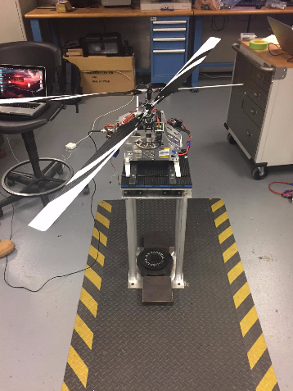

Figure : Final Test Setup of K-MAX on Vibration Isolating Test Stand

# Statement of Work

## Problem Definition

The existing model K-MAX style helicopter, developed by the CCSU Department of Engineering, experiences high vibrational frequencies during operation. A portion of the energy supplied to the rotors is being dissipated in the form of mechanical vibration and is therefore adversely affecting the helicopter’s performance. The vibrations are being transmitted to the components that make up the helicopter as well as to the test stand which it is currently mounted to. As a result, the helicopter does not appear to be stable enough to operate in flight. Currently, there is no system in place dedicated to reducing the amount of vibrations felt by the K-MAX. Consequently, it is desirable to develop a damping system to allow the helicopter to function as intended and to optimize its performance. An analytical approach will be used to design a system for damping the vibrations felt by the K-MAX. Multiple approaches including a new test stand, a mass damping system, and proper balancing will then be used to dampen the vibration seen by the helicopter.

## Engineering Process

A finite element model will be analyzed to generate an analytical understanding of the behavior of the helicopter’s vibrations. From the finite element model, critical modal locations will be established and investigated as potential damping locations. The analytic results will then be compared and verified through a series of tests on the actual K-MAX using an accelerometer. The accelerometer is employed to measure the actual vibrational frequencies that the K-MAX experiences under normal operating rotor speeds. Data from the accelerometer will then be analyzed using signal analysis software in MATLAB. Once the finite element model is confirmed using physical test data, a damping system will be designed with the intention of reducing the vibration that the K-MAX experiences. The system will then be manufactured and installed on the existing K-MAX helicopter. Subsequent physical tests using the accelerometer will once again be done to evaluate the effectiveness of the damping system and to verify the results.

The software used to analyze the K-MAX helicopter was CREO, Autodesk Inventor, and MATLAB. The CAD models of the K-MAX were created in CREO based on the currently built K-MAX. Those CAD models were then imported into Autodesk Inventor, which can be used as a finite element analysis software. This was used to find the critical modal locations on the body of the helicopter. Once these were found an accelerometer was attached to the helicopter at these locations which transmitted the actual vibration of the helicopter to MATLAB’s signal analysis software. Using MATLAB the real vibration experienced by the helicopter was able to be analyzed and compared to the Autodesk Inventor results.

## Design Constraints

The damping system must be incorporated into the existing K-MAX helicopter. Therefore, some basic specifications such as the size of the helicopter body and the configuration of the two rotor assemblies dictate the magnitude and placement of the damping system. The system intended for damping vibrations must be designed as to not interfere with the overall functionality of the helicopter. Additionally, the critical modal locations found using finite elements must be tested using the accelerometer to verify the analysis results. The accelerometer contains a threaded hole which can be used to bolt to the K-MAX. However, the critical modal locations that should be tested may be in areas on the helicopter that are challenging to bolt the accelerometer into. The overall size and shape of the accelerometer will limit the feasible locations where it can be mounted to the K-MAX to take vibration readings. Another aspect that will constrain the outcome of the project is time. Since the engineering process adapted to complete this task involves a lot of analytical and testing activities. Effective time management is integral to completing all tasks by the end date and achieving the desired outcomes as the total time for the project is only 9 months. As shown in Figures 2-4, the goals for the project had been set up with dates that they needed to be accomplished by.

## Alternative design ideas and methods

Many applications have been developed over the years to dampen vibrations in helicopters. Some possible concepts include using alternative materials for certain components, applying pendulum dampers to the blades or by using a mass-spring damping system. Alternative design ideas that may help to dampen vibrations felt by the current K-MAX design include re-designing the test stand which it is currently mounted to. As of now, when the helicopter is in operation, vibrations from the natural frequency of the rotating blades are transferred to the test stand. In turn the test stand begins to oscillate, and returns a lot of that kinetic energy back into the helicopter. This phenomenon amplifies the amount of vibrations that are felt by the helicopter. By making the test stand more rigid, the oscillations omitted by the blades will not be transmitted as easily between the helicopter and test stand. This alternative method will help to reduce vibrations on the K-MAX during testing operations. Moreover, this will help to verify the analysis results and provide credible outcomes that can be used for design.

Another possible way that vibrations can be dampened is by re-designing the hardware used to build the helicopter and its body. If adjustments are made to make the fuselage more rigid, the vibrations transmitted by the blades and rotors may not be carried as easily throughout the entire craft. This can be accomplished by using components such as fasteners with locking features that do not allow them to back-out due to vibration. If the fasteners that hold the frame together are kept tight in their place, it can potentially reduce the propagation of mechanical vibration. Applying features to the helicopter that make the fuselage more rigid may help to reduce vibration during flight and help to improve overall performance.

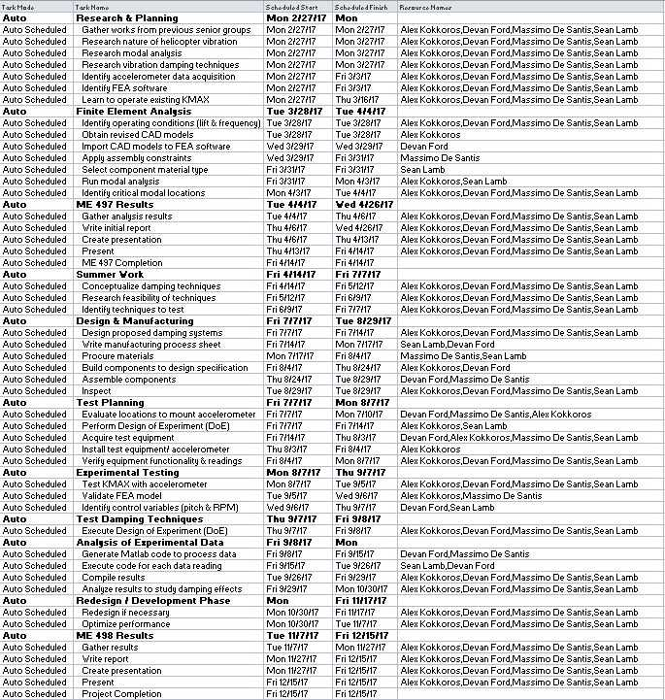

Figure : Tasks and Schedule of Project

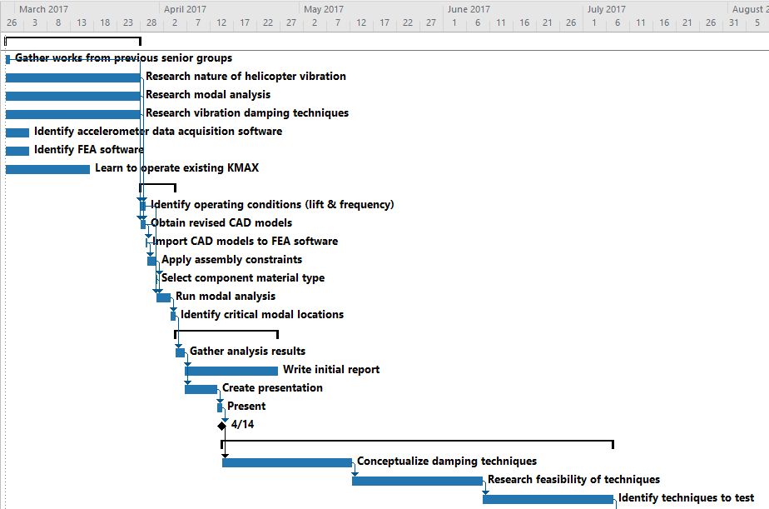

Figure : Gantt Chart of First Semester's Work

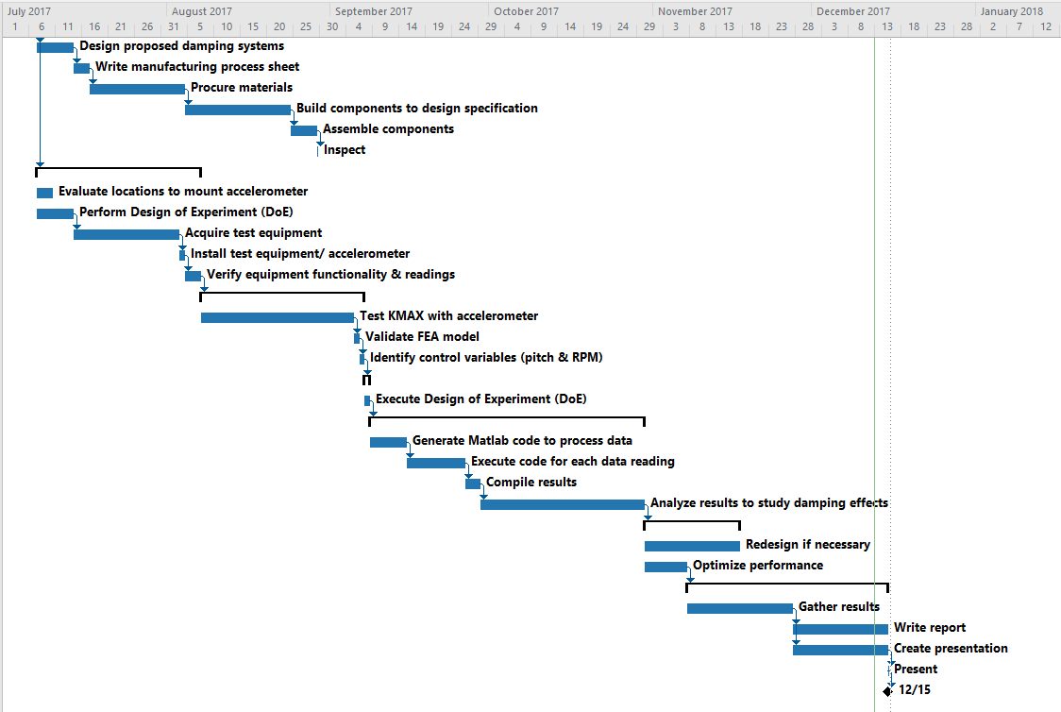

Figure : Gantt Chart of Second Semester's Work

# Results

## Selection of best design idea

Using one method of vibration damping would not be enough to eliminate the excessive amounts of vibration that the K-MAX experiences. Multiple methods to dampen the vibration were researched and accessed to see which would have the largest impact. The first method that was designed and implemented was the building of a new test stand. This was also the most necessary of all of the methods. The old stand that the K-MAX was attached to influenced the vibration that it was already experiencing. Without building a sturdier test stand that helped to eliminate the vibration that was transferred back into the helicopter the vibration that came solely from the K-MAX itself would not have been able to be measured.

As for vibration, damping of the helicopter itself the logical design idea was the mass damping system. Mass damping systems are used in a variety of vibration damping applications even outside of helicopters. It is a method that is known to effectively eliminate vibration and has ample examples and data to research from. Mass damping systems are also used in just about every helicopter currently in production. These systems are also pertinent to the analysis already being done to the helicopter. To analysis the vibration of the helicopter it was put into an FEA analysis where modal locations of high displacement due to vibration were located. These modal points are the places that that the masses of a mass damping system need to be placed to have the most efficient damping of vibration.

Balancing of the rotors was the next design idea that was chosen for the project. All helicopters go through balancing of their blades and rotors before they are ready to fly. The balancing is a necessity for the K-MAX to have enough of its vibration removed that it would be able to fly. The blades of the K-MAX are already calibrated, but nothing was being done to the rotors to make sure that they were properly aligned. The imbalance of the rotor is an actual source of the vibration that is felt by the K-MAX. The balancing of it was a way to not just dampen the vibration, but to stop the vibration from ever being produced within the helicopter.

The final method used to dampen the vibration was done because, though needed, it was also the simplest and most cost effective way to dampen the vibration. By adding rubber washers to the K-MAX a material was added into the helicopter that would be able to absorb some of the vibration instead of just transferring it to the next part. These washers were placed on all the bolted connections of the helicopter ass these connection parts had the greatest potential to have excessive vibration. Being already manufacturer, cheap to buy, and easy to install made them an easy choice to add to dampen the overall vibration of the helicopter.

Many of the ideas for damping the vibration of the K-MAX were eliminated based off the feasibility of the method. Some of the design ideas were unable to be executed on the K-MAX. For example, the pendulum absorber would have been an effective way to dampen the vibration but the manufacturing of the pendulum, due to the small size of the model K-MAX, would have been impossible to do especially with the equipment that was accessible for the project. The design of the pendulum absorber is also very labor intensive and sue to the time constraints of only 9 months would have been very difficult to accomplish. Similar issues eliminated the rotor support for the as a design idea that could be applied to the K-MAX.

## Engineering analysis of solution

To quantitatively approach the vibration profile of the KMAX helicopter at a specific RPM, root mean square (RMS) and peak-to-peak are to be calculated over a specific time interval. RMS yields an approximation of the power or strength of a vibration profile, as RMS is defined as

|  |  |  |
| --- | --- | --- |
|  |  | (1) |

while peak-to-peak is measured as the vertical distance from the highest peak to the lowest peak, as shown below in Figure 5.

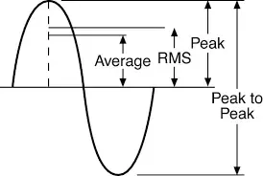

Figure : Diagram of Wave Characteristics

The test stand has critical damping properties that are essential to minimizing vibration. The equation of motion,

|  |  |  |
| --- | --- | --- |
|  | $$m\ddot{x}+c\dot{x}+kx=F\left(t\right)$$ | (2) |

yields important information to describe the motion, or vibration, of the test stand. Knowing a force function, the displacement of the test stand can be calculated, and is expected to be minimal. Knowing the mass m, the damping coefficient c and spring constant k are to be determined using logarithmic decrements, where data of the displacement from an impulse input force is used, as shown below in Figure 6

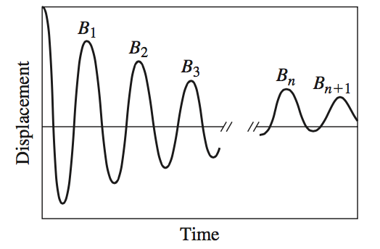

Figure : Diagram of Logarithmic Decrements

The logarithmic decrement is calculated by,

|  |  |  |
| --- | --- | --- |
|  | $$δ=\frac{1}{n}ln⁡(\frac{B_{1}}{B_{n}+1})$$ | (3) |

From the logarithmic decrement, the damping ratio is calculated,

|  |  |  |
| --- | --- | --- |
|  | $$ζ=\frac{δ}{\sqrt{4π^{2}+δ^{2}}}$$ | (4) |

Knowing the period P, or the time interval over the specified number of cycles, the damped frequency $ω_{d}$ and undamped frequency $ω_{n}$ are calculated,

|  |  |  |
| --- | --- | --- |
|  | $$ω_{d}=\frac{2π}{P}= ω_{n}\sqrt{1-ζ^{2}}$$ | (5) |

Finally, the spring constant k and the damping coefficient are calculated,

|  |  |  |
| --- | --- | --- |
|  | $$k=mω_{n}^{2}$$ | (6) |
|  | $$c=2ζ\sqrt{mk}$$ | (7) |

The half-power bandwidth method is also to be used to determine the damping ratio for a specific frequency that appears in the Fourier transform of the waveform as shown in Figure 7.

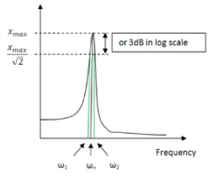

Figure : Diagram of Half Power Bandwidth Method

Examining an individual peak, the quality factor Q and damping ratio are calculated,

|  |  |  |  |  |
| --- | --- | --- | --- | --- |
|  | $$Q=\frac{ω_{n}}{ω_{2}-ω_{1}}$$ | | | (8) |
|  | | $$ζ=\frac{1}{2Q}$$ | (9) | |

Recalling the criteria for the damping ratio,

|  |  |  |
| --- | --- | --- |
|  | $$ζ \left\{\begin{aligned}=0, undamped \\ <1, underdamped \\ =1, critically damped \\ >1, overdamped\end{aligned}\right.$$ | (10) |

Frequencies that have damping ratios that are close or equal to 0 will indicate major sources of vibration. Picking distinguishable peaks in the Fourier transform while knowing the characteristic of such a frequency, the significance of such a frequency can be determined regarding the vibration profile. For instance, if the frequency of the motor is known, the damping ratio can be determined using the half-power bandwidth method, which will indicate whether the motor is undamped, underdamped, etc.

## Cost analysis of design

With the equipment used for testing and building the different dampening technics being donated by Central Connecticut State University the total project costs were fairly ow. The only testing equipment that was purchased was dial gauge to balance the rotors of the K-MAX. The only other costs came from the materials used to build the test stand and to dampen the vibration in the helicopter. A table of materials purchased and their respective costs can be found in Table 1.

Table 1: Cost Analysis

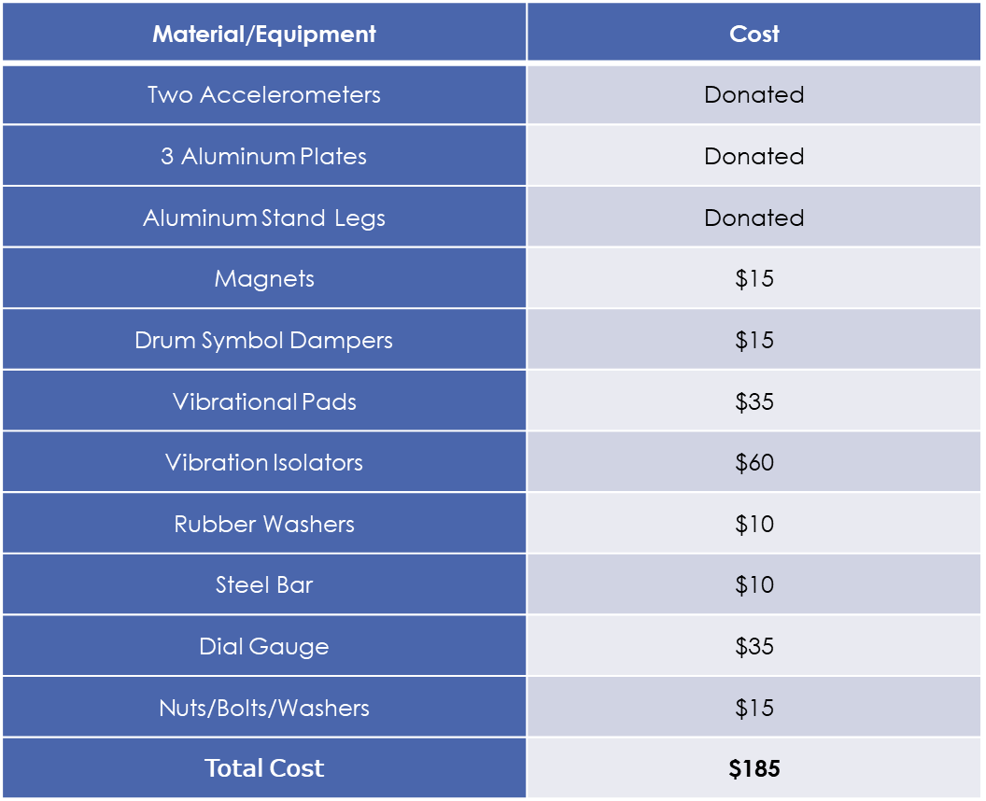

The total out of pocket cost of the vibrational damping of the K-MAX helicopter came out to be $195. If not for the donated equipment, the cost would be much higher, with the two accelerometers alone costing a total of $1600. The machinery used to construct the test stand like the drill press, welding equipment, and band saw was provided by Central Connecticut State University. The prices of the damping on the helicopter were meant to be kept low. Aluminum was used for the building of the test stand because it is a cheaper material and the plates and legs that were donated were aluminum. Rubber washers were meant to help eliminate some of the transfer of vibration within the helicopter. Magnets and drum symbol dampers were also a cost effective was to build a mass damping system on the K-MAX.

## Engineering Drawing or Parametric Models

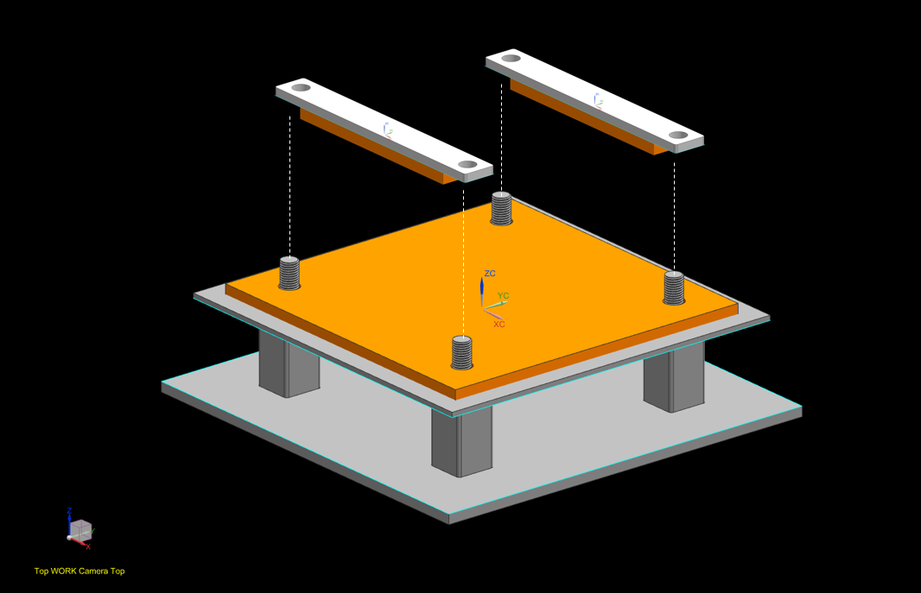

Figure : CAD Drawing of Initial Test Stand Design

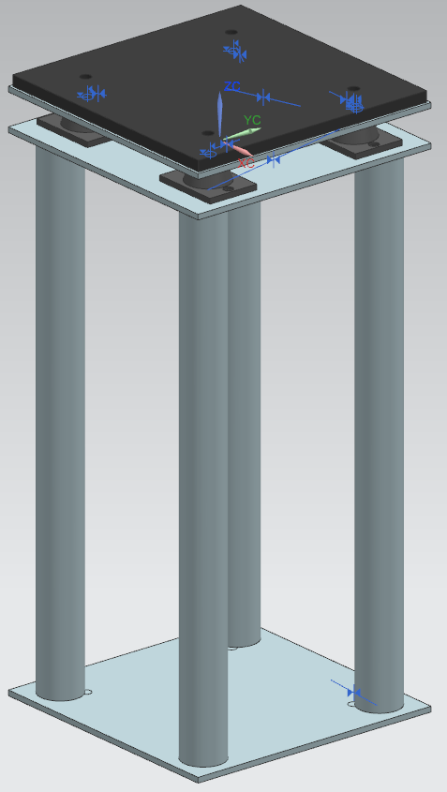

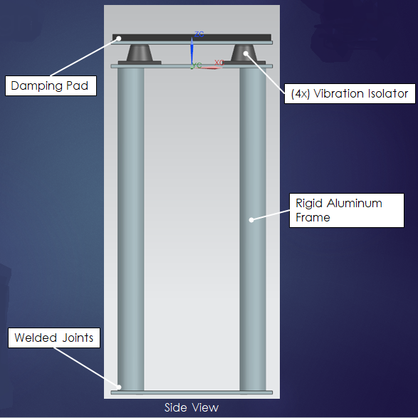

Figure : CAD Drawing of Isometric and Side View of Final Test Stand Design

## Project Deliverables

## 1. Finite Element Analysis

For the analysis, portion of the project a finite element analysis was performed on the existing models of the K-MAX helicopter. From this analysis estimates of the displacement, caused by vibration, within the body of the helicopter were able to be seen. Renderings of this displacement were created using Autodesk Inventor as seen in Figure 7. Through this analysis the modal locations of the helicopter were identified which allowed for the creation of a mass dampening system.

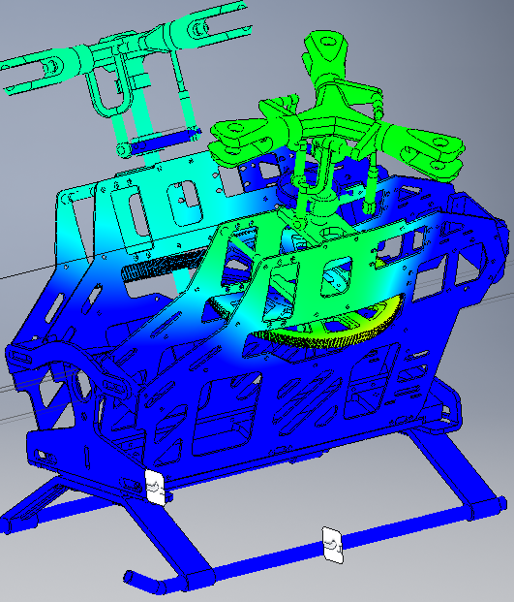

Figure : Modal Analysis of Model K-MAX Helicopter Created using Autodesk Inventor

Modal Analysis through FEA was conducted a parametric model of the K-Max helicopter in order to determine natural frequencies of the structure and points of greatest deflection. A CAD model of the K-Max helicopter was drafted and assembled in a CREO. The model was then imported into Autodesk Inventor in order to perform finite element analysis. Autodesk Inventor’s stress analysis tool was used in order to conduct modal analysis on the structure. The model was loaded into the software and the geometry was converted automatically. Constraints were added manually to the joining pieces of the model. The model was then fixed at the feet of the helicopter in order to simulate the constraint of the actual helicopter to the test stand. The modal analysis was performed from 0-100 Hz to locate the natural frequencies.  This range was chosen because the exciting frequency produced from the motor was determined to be within this range. There are many errors that are associated with finite element analysis; in order to gain confidence in the model and possibly reduce errors associate with the model, multiple iterations of modal analysis were conducted with reduced assemblies. These reduced assemblies eliminated parts and constraints associated in the model to gain a wider range of possible natural frequencies of the actual K-Max. The common natural frequencies, in which resonance would occur were obtained from these iterations of modal analysis to be about 40, 59 and 80 Hz.

Common points of the model that resulted in the greatest deflection were also present throughout the multiple iterations of modal analysis. Although it was determined through research that the actual values of deflection obtained through modal analysis may not be accurate, the points at which they occur are usually representative of the actual geometric locations. Throughout each analysis conducted, the common points of greatest deflection were located at the top area of the body plates. These areas were determined to be the most optimal in which to add mass to dampen the total vibration of the K-Max.

## 2. MATLAB Analysis

Once the analysis of the K-MAX was complete, a way to collect data from the accelerometer was needed. Unfortunately, the manufacturer of the accelerometer does not make a software to collect data. Instead, a MATLAB code, as seen in Figure 8, was developed to read the audio file that is created by the accelerometer and produce the data to be analyzed. The MATLAB code interpreted a sound file, which could be obtained from the accelerometer, into a wave form as well as RMS, peak-to-peak, and FFT values which will be discussed in depth.

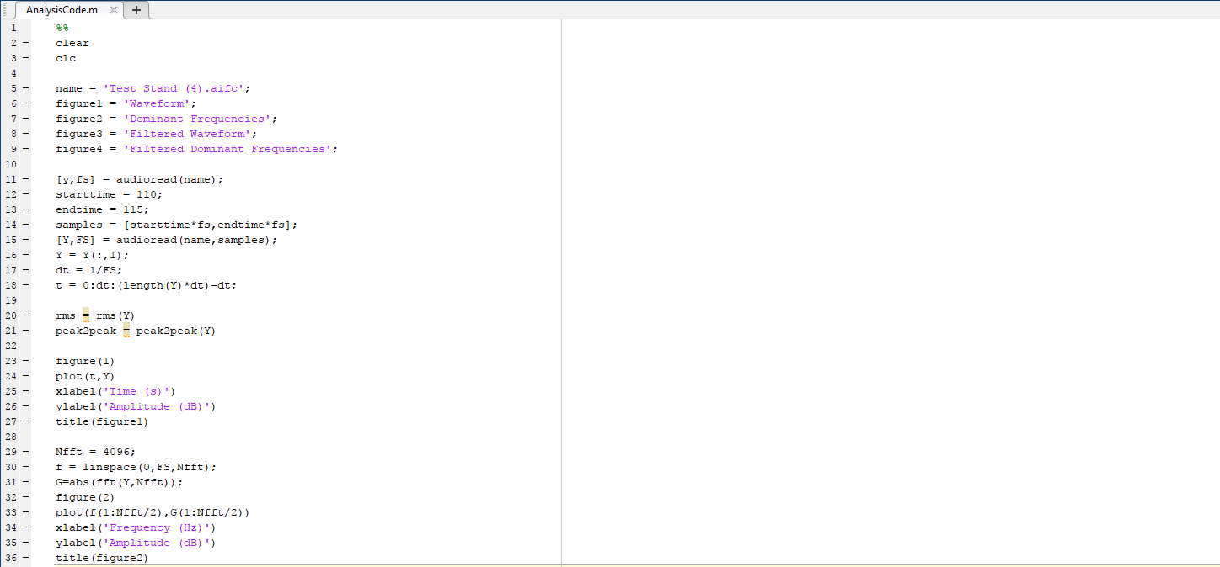

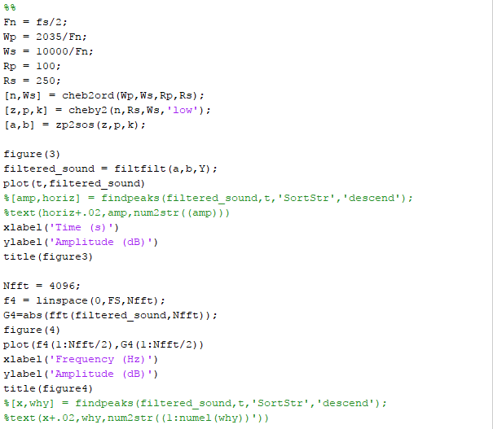

Figure : MATLAB Code Used to Interpret Accelerometer Data

## 3. Manufacturing Test Stand

In order to collect accurately collect the vibrational data from the K-MAX a new stand was built for the tests to be done on.  As previously described the old test was unit fit for collecting any information on vibration as it was not rigid enough and would shake along with the K-MAX, amplifying the vibration.  The new test stand was designed and manufactured to be rigid and allow for the isolation of the vibration that is generated from the K-MAX.

When designing the new test stand, specific goals were kept in mind such as having the ability to remain stationary and fixed to the ground while the K-Max is at full operation speed, creating a lift of about 20 pounds. The new stand had to have correct dimensions in order to properly constrain the legs of the helicopter to the surface of that stand. Also, the stand had to be made with design and material in order to isolate vibration to the helicopter and not allow these forces to propagate through the stand.

After researching methods of isolating vibration, it was decided that vibration damping material should be used in areas in which contact was made between the helicopter and the test stand. It was also decided that vibrational isolators should be used between the surface where the helicopter is fixed and the supporting structure of the test stand. The final design of the test stand can be seen in Figure 9. A rigid, four leg support structure was designed, with an additional surface separated by vibrational isolators. The testing surface was designed in order to constrain the helicopter with vibration damping material at the contact areas. Aluminum was used for the support structure of the test stand as it was the most cost effective material which provided the required rigidity.

The vibration damping material, as well as the vibrational isolators were purchased from an online retailer after searching for the most cost effective suppliers. The Aluminum stock was obtained through the Engineering Department of Central Connecticut State University and through donations by Paradigm Precisions.

The design of the test stand was done through the 3D modeling software NX and the manufacturing took place in the Manufacturing Laboratory at Central Connecticut State University. A band saw was used to cut the Aluminum legs of the test stand to size and a press was used to drill holes in the test stand necessary to provide clearance for the studs of the vibrational isolators. The legs were attached to the surfaces of the test stands with TIG welding performed at Paradigm Precision. Adhesive material was used to attach the vibration damping material to the testing surface.

The final assembly of the test stand was made up of three Aluminum Plates, one of which was layered with damping material, four hollow Aluminum legs, two Aluminum pieces layered with damping material to constrain the helicopter, and four vibrational isolators along with threaded bolts and washers for attachment.

## 4. Mass Damping System

With a method to test, a new test stand to test on, and the modal locations known, a mass damping system was able to be created for the K-MAX. For this magnets and gel masses, originally designed to be drum symbol dampers, were attached at the modal points found in the finite element analysis. The gel masses are flat circular masses that would not attach on their own to the helicopter. To attach them the gel masses were placed on both sides of the modal locations on the plate and the magnets were placed on top of them to hold them in place. This set up can be seen in Figure 12. The magnets also added an extra mass to the gel masses as well as holding everything in place while the K-MAX was running. The K-MAX was then tested, running at different pitch angles, with and without both the test stand and the gel masses. The data was collected with the accelerometer and then interpreted using the created MATLAB code.

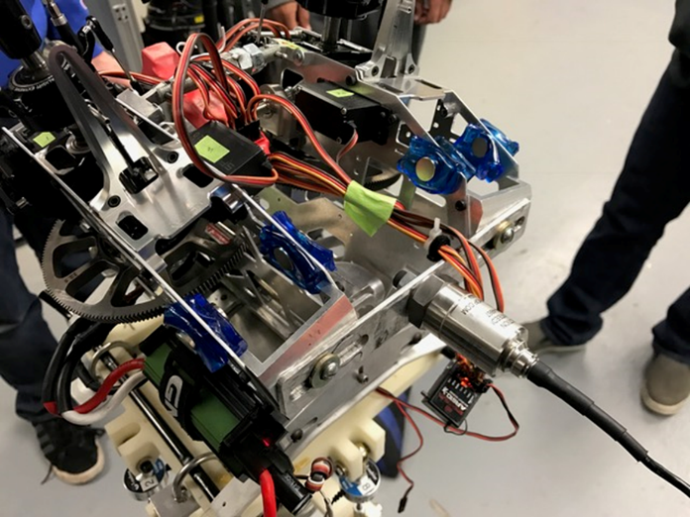

Figure : Test Setup with Gel Masses Placed on K-MAX

## 5. RMS and Statistical Analysis

RPM data was provided by the other KMAX groups, which was plotted in excel as shown below in Figures 12-14. In order to get the RPM for a specific time of the vibration data, the two sets of data had to be synchronized. The RPM data was collected at every half second, so time values could easily be calculated. Once these two sets of data were synchronized, five random data points were chosen at a specific time, and the RMS and peak-to-peak values were calculated in MATLAB over the duration of a half second. Because RMS is simply $\sqrt{2}$*(peak-to-peak), RMS alone will be sufficient to measure vibration.

Figure : Graph of RPM vs RMS for Tests Run at Different Pitch Angles

Figure : Graph of RPM vs RMS for Tests With and Without the Gel Masses

Figure : Graph of RPM vs RMS for Tests Run With and Without the Vibration Isolating Test Stand

Looking at these figures at first glance, it is easy to see that RMS tends to increase as the RPM increases, meaning that there is significantly more vibration the faster the blades of the helicopter spin. Figure 4 shows a very chaotic scatter plot, where pitch angle does not seem to show any obvious correlations. Looking at it closely, however, a 14.5° pitch does seem to have higher RMS values, especially in the 500-700 RPM range. Looking at Figure 5, there was simply not enough data gathered without the gel masses, so no real conclusions can be drawn. Next, looking at Figure 6, RPM’s within the same 500-700 range tend to have a much lesser RMS using the designed vibration damping stand rather than the force sensing stand. Unfortunately, more data would need to be gathered in the upper RPM range to draw more conclusions. Based upon these tendencies, vibration of the helicopter can be more easily controlled at RPM’s within 500-700. RPM’s outside of this range, however, are more chaotic and would need greater measures of vibration control.

To gain a more concrete understanding of the effects on vibration, a statistical analysis was performed. This statistical analysis was performed in MINITAB and revealed which results collected were statistically significant. It allowed for a comparison of all of the variables to see which helped or worsened the vibration in the K-MAX.



Figure : Main Effects Plot for Different Variables Used During Testing

The main effects plot for RMS shows that each variable has a difference in the mean RMS for that variable. In this plot and in the following plots, the a 0 and a 1 for the variable “Stand” indicates the force stand and the damping stand, respectively, and the absence of gel masses and applied gel masses, respectively. If any horizontal lines for a specific variable were shown in this plot, then immediately it can be concluded that that variable has no effect on the RMS. Although the mean of RMS is different for each variable, it must be determined whether or not the effect is statistically significant.



Figure : Interval Plot of RMS at Different Pitch Angles

Looking at the interval plot of RMS for all three variables, it is difficult to identify any pair that exist outside of each other’s confidence interval. There does, however, exist two pairs, where 14° pitch angle, gel mass applied, and damping stand used differs from the same criteria, only using 14.5° pitch angle, as circled in red on the right hand side on the plot. This same 14.5° pitch angle, gel mass, damp stand interval also differs from 9° pitch angle, no gel mass, force stand used. Of these three combinations, the 14° and 9° pitch angles are preferred, as they have a lower RMS range than the 14.5° pitch angle. As mentioned earlier in the scatter plot of RPM vs. RMS for different pitch angles, 14.5° seemed to have larger RMS values, especially in the 500-700 RPM range.



Figure : Interval Plot of RMS With and Without the Gel Masses and Vibration Isolating Stand

Because the interval plot for all three variables only yielded different pairs with combinations that were too specific, a simpler interval plot was generated focusing on the damping techniques alone, the test stand and gel masses. Unfortunately, not enough data was gathered for the absence of the gel while using the damping test stand, as challenges had arisen with the model helicopter. There is, however, a very clear distinction between the test stand while using the gel masses. This interval plot shows that using the force stand led to a significant increase in vibration than using the damping stand.

The p-values of this analysis are important indicators in determining whether or not a variable has a statistically significant impact on the RMS. The null hypothesis for this analysis is that each variable, the pitch angle, gel mass, and test stand, have no effect on the RMS. An α value of 0.05 was assumed for this analysis. For each variable, the p-values were:

Table 2: Probability Values of Different Test Variables

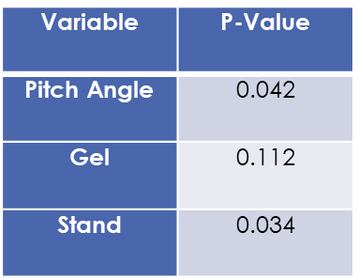

Both the pitch angle and test stand yielded p-values that were greater than α, meaning that the null hypothesis can be rejected, concluding that both of these variables had a significant effect on the vibration of the helicopter. The gel, however, having a p-value greater than α, did not have a significant effect on vibration. This may be due to the fact that there was not enough data taken without the gel masses applied.

MINITAB has also provided the regression model for RMS with respect to each variable:

RMS = 0.11740 - 0.0198 Pitch Angle_9.0 - 0.0115 Pitch Angle_9.5 + 0.0244 Pitch Angle_12.0

- 0.01179 Pitch Angle_12.5 - 0.0183 Pitch Angle_14.0 + 0.01238 Pitch Angle_14.5

+ 0.0246 Pitch Angle_15.0 - 0.01133 Gel_0 + 0.01133 Gel_1 + 0.01189 Stand_0

- 0.01189 Stand_1

Looking at the pitch angle specifically, the p-values for the coefficients are:

Table 3: Probability Value of Different Pitch Angles Used During Testing

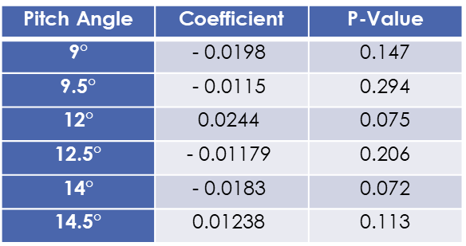

All pitch angles have p-values greater than α of 0.05, indicating that these coefficients are good indicators of the RMS. Judging by the sign of these coefficients, pitch angles of 9°, 9.5°, 12.5°, and 14° significantly reduced the vibration, while pitch angles of 12° and 14.5° significantly increased the vibration. 15° was actually considered an unusual observation and is therefore should not considered, which is also due to having insufficient data for that pitch angle.

## 6. Test Stand Logarithmic Decrements

To analyze the damping stand itself, logarithmic decrements were used as previously discussed. Suspending the test stand so that it was not in contact with anything except the tether, an impulse force was applied with a rubber mallet at the steel cross members. Using the Digiducer accelerometer, an audio file was created and filtered using MATLAB.

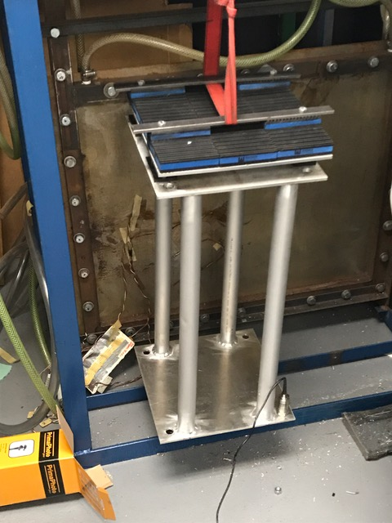

Figure : Suspending the Test Stand

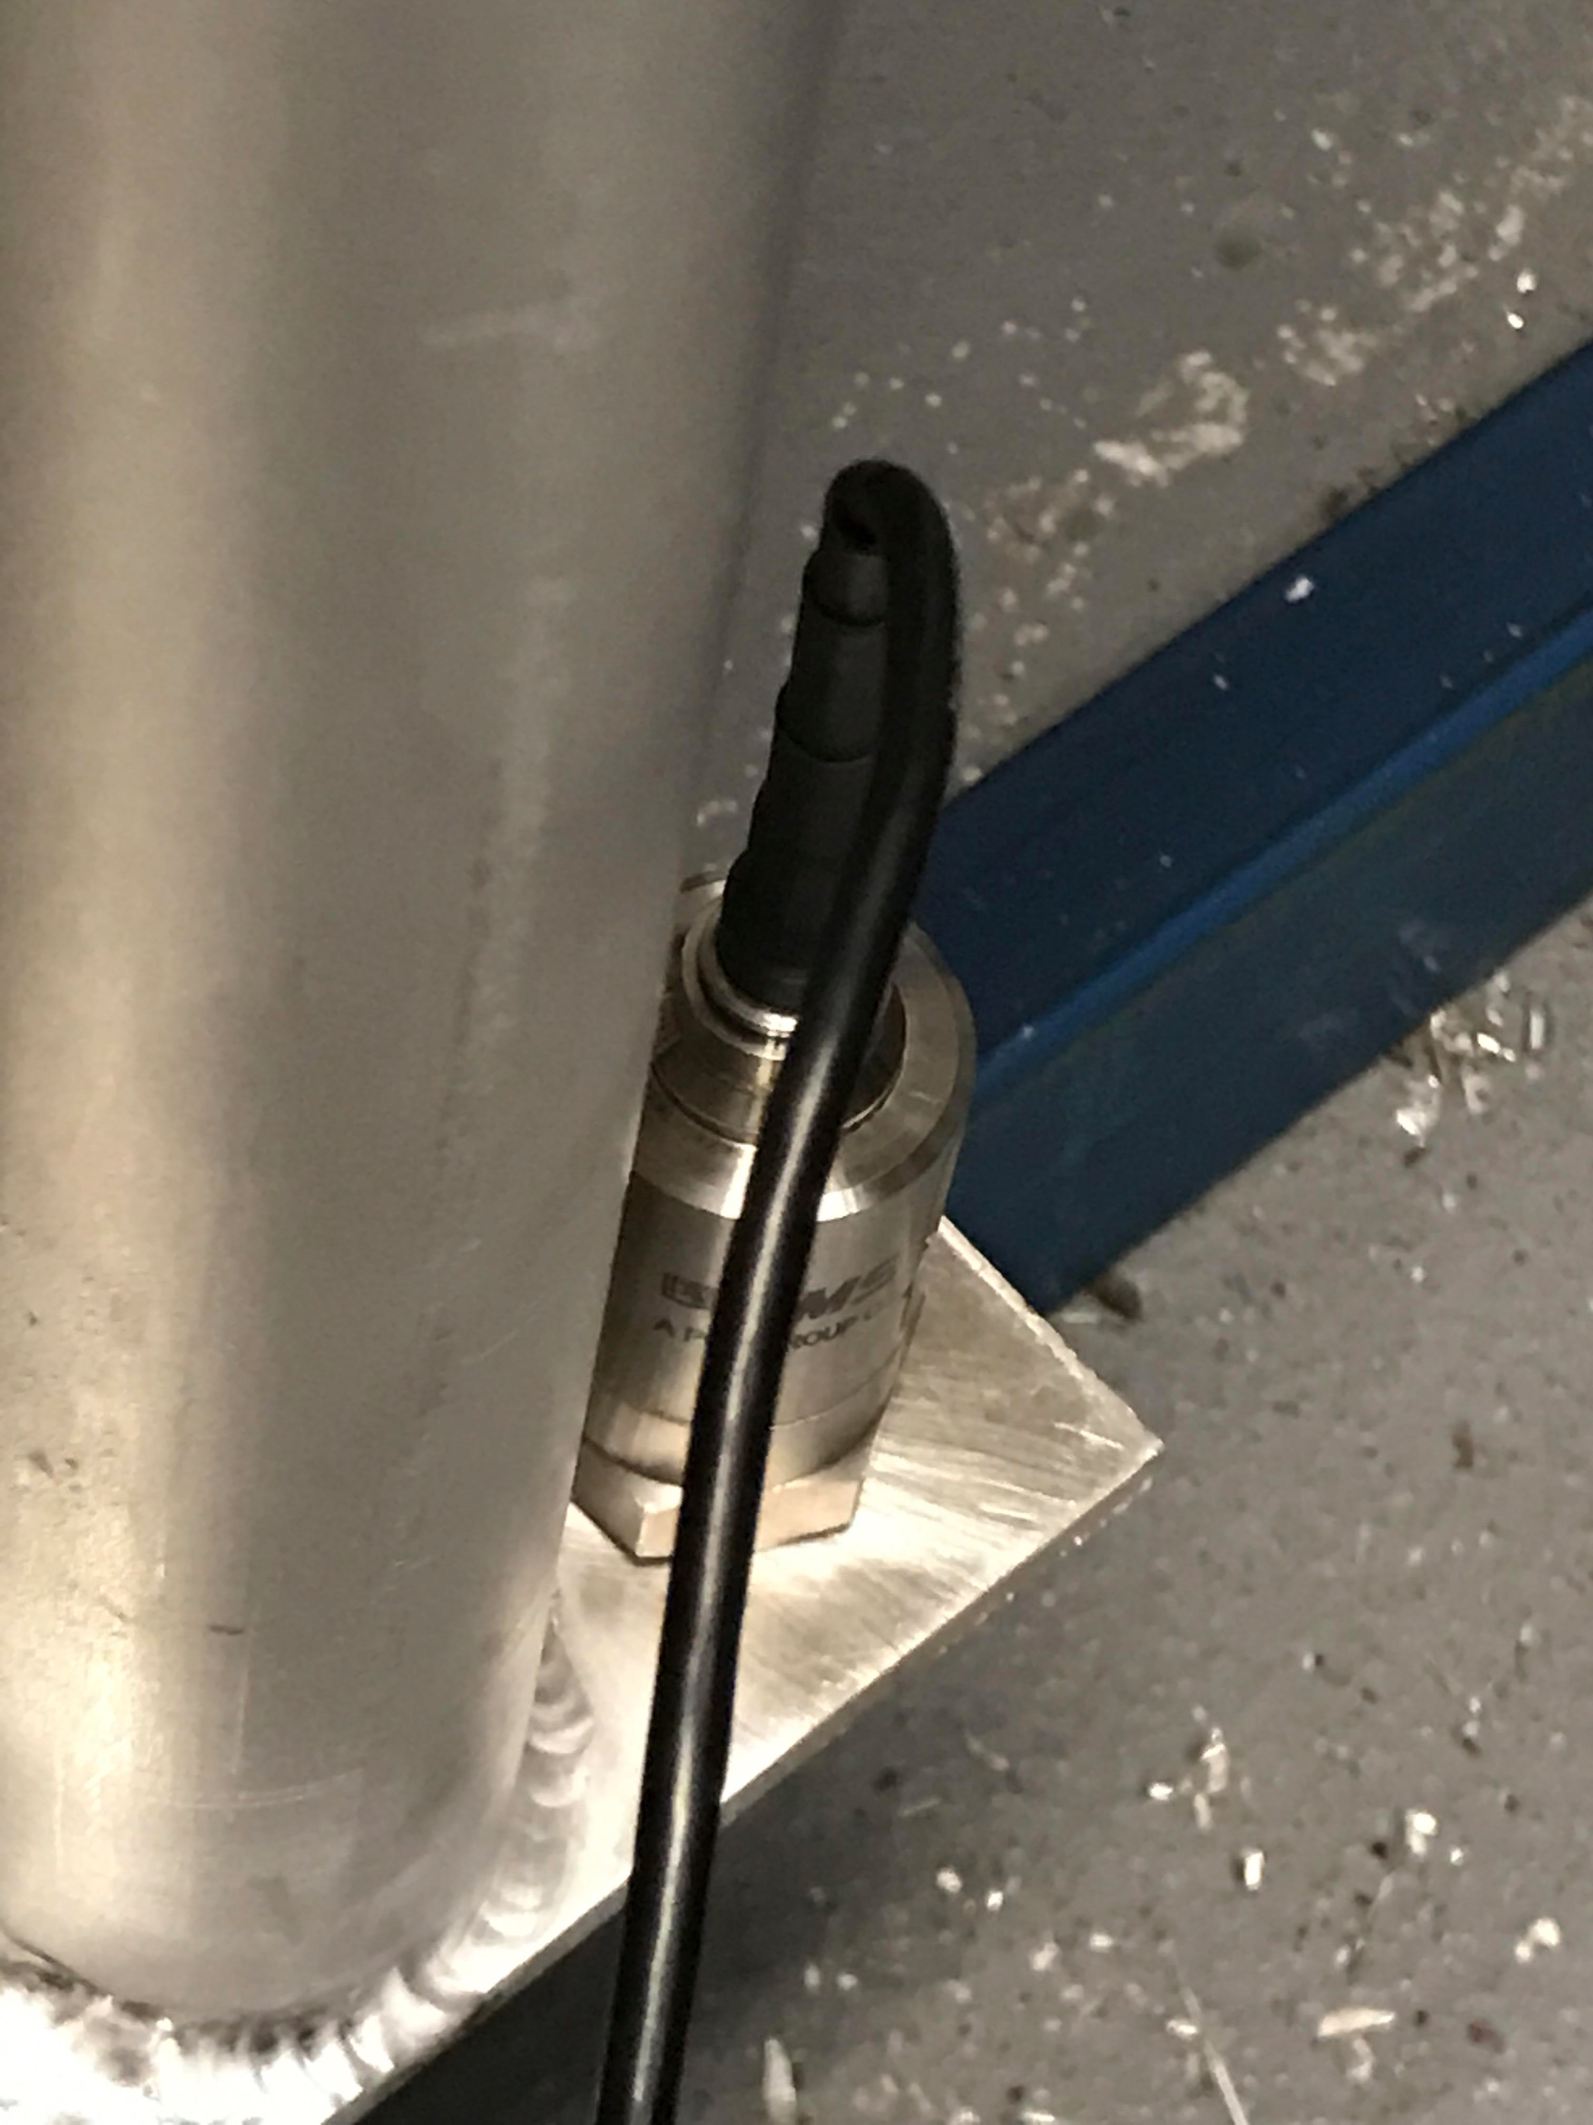

Figure : Mounting of Accelerometer

Reading the audio file in MATLAB, the following waveform is produced. The stand was lightly struck with the rubber mallet twice as shown. It can easily be seen that the displacement immediately dies out over a time of roughly 1.5 seconds.

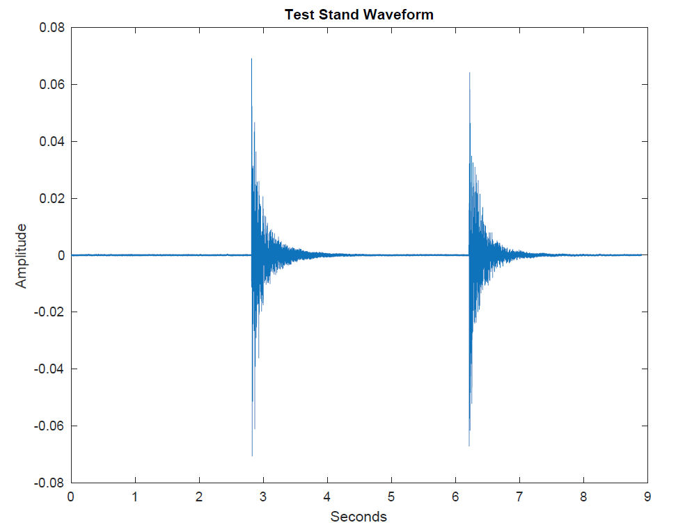

Figure : Waveform Impulse of Applying Force to Stand

Zooming in on the first impulse and using a filtering function in MATLAB, the peaks are clearly revealed as shown below in Figure 21,

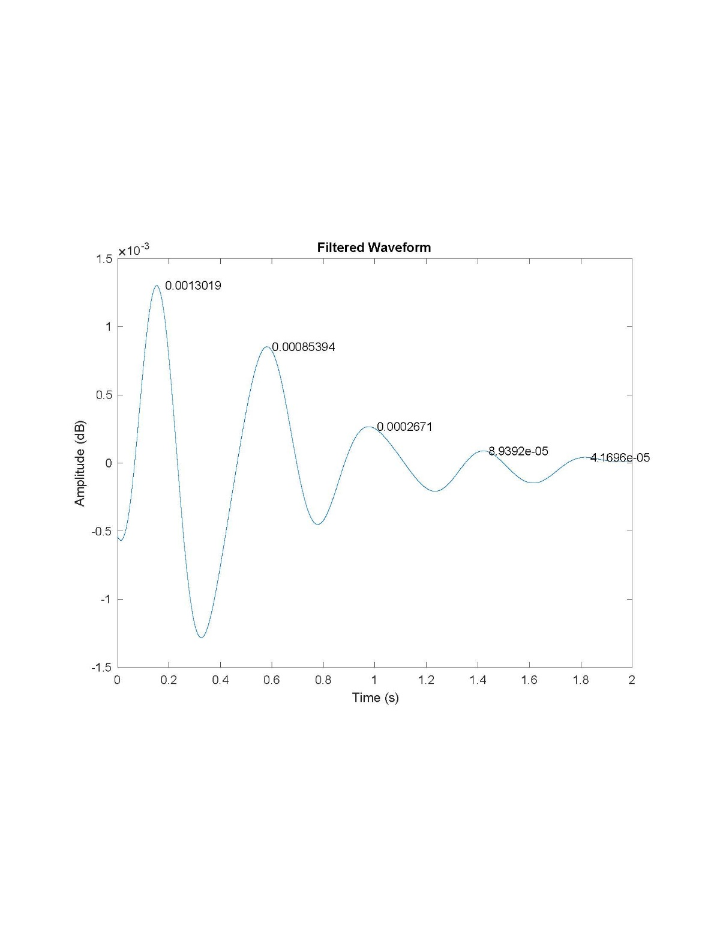

Figure : Filtered Waveform Impulse of Applying Force to Test Stand

The logarithmic decrement is calculated from these peaks,

|  |  |  |
| --- | --- | --- |
|  | $$δ= \frac{1}{n} \ln{\frac{B_{1}}{B_{n}+1}}=\frac{1}{4} \ln{\frac{0.0013019}{4.1696 x {10}^{-5}}=0.860294}$$ | (11) |

Where the damping ratio is calculated,

|  |  |  |
| --- | --- | --- |
|  | $$ξ= \frac{δ}{\sqrt{{4π}^{2}+δ^{2}}}=\frac{0.860294}{\sqrt{{4π}^{2}+{0.860294}^{2}}}=0.135654$$ | (12) |

Knowing that the period P is equal to 1.55 seconds / 4 cycles or 0.3875, the damped frequency is,

|  |  |  |
| --- | --- | --- |
|  | $$ω_{d}= \frac{2π}{P}= \frac{2π}{0.3875}= 16.215 Hz$$ | (13) |

Where the undamped frequency or natural frequency is found,

|  |  |  |
| --- | --- | --- |
|  | $$ω_{n}= \frac{ω_{d}}{\sqrt{1 - ξ^{2}}}=\frac{16.215}{\sqrt{1 - {0.135654}^{2}}}=16.366 Hz$$ | (14) |

Measuring the mass of the test stand to be 18.2 lbf, equivalent to 0.565 lbm and recalling the equations to obtain the spring constant k and damping coefficient c, the equation of motion for the test stand is found to be,

|  |  |  |
| --- | --- | --- |
|  | $\ddot{x}+2.5051 \dot{x}+150.84 x=F(t)$ | (15) |

## 7. Vibration Characteristics

For each run that vibration was measured on the helicopter, the waveform, Fourier transform, and spectrogram were plotted. The RPM curve is shown below in Figure 22. 120417 (14) represents the nomenclature used for each run.

Figure : Sample of RPM Curve Found While Testing K-MAX at a Pitch Angle of 14 Degrees

The respective spectrogram is also shown below in Figure 23. What the spectrogram represents is the Fourier transform calculated for a specific time interval, and is then calculated at the next time interval until the entire time length of the file is covered. With the spectrogram, the most dominant frequency can be seen as it changes over time. Therefore, the vertical axis represents the frequency, the horizontal axis represents the time, and the color represents the intensity of the specific frequency.

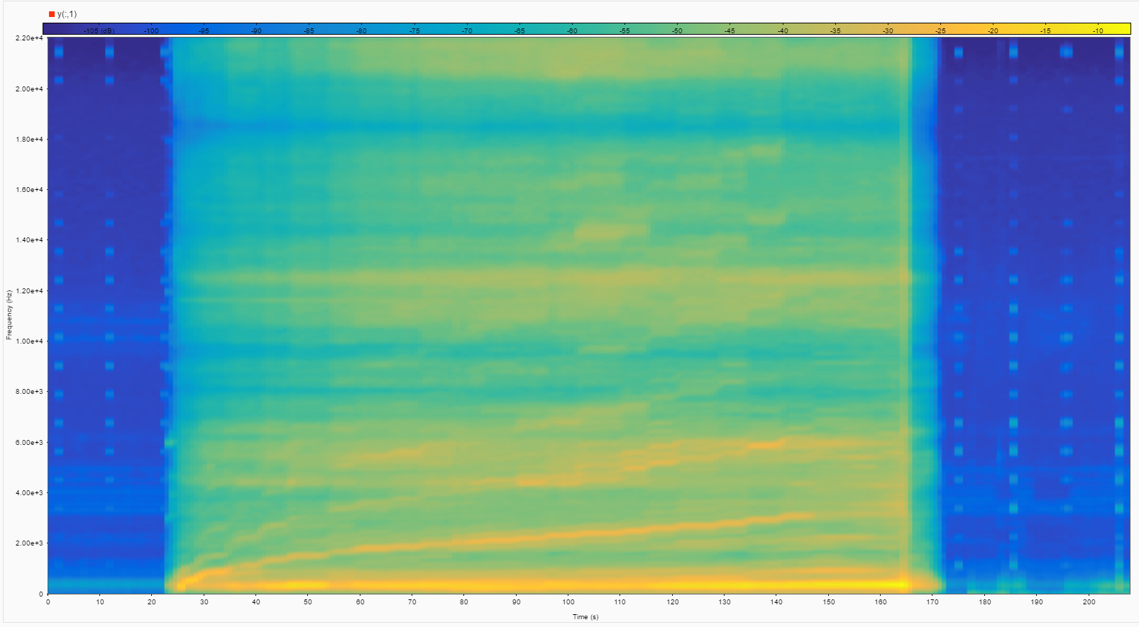

Figure : Corresponding Spectrogram To Figure 22s RPM Curve

The orange line seen starting at 0 and rising to roughly 3kHz is witnessed to have the exact same shape as the RPM curve in Figure 23, however, this is but a harmonic of the RPM, not the actual RPM itself. This line was actually found to be the RPM of the driver gear multiplied by the number of teeth it has, or the RPM of the main gears multiplied by the number of teeth they have. The faint lines above this line are harmonics of this source, as they resemble the same shape and have been witnessed to be a factor of that specific frequency. The RPM’s of the main gears and driver gears are somewhere adjacent to the bright orange horizontal line witnessed at the bottom of the spectrogram, which was found to be some sort of combination between both gears.

Looking at a half second time interval for this run at 116 seconds, the RPM of the main gears/blades was measured to be 893, or about 15 Hz, as shown below in Figure 24. Two other peaks are witnessed adjacent to this peak, as they represent harmonics twice and triple the value of the 15 Hz, respectively.

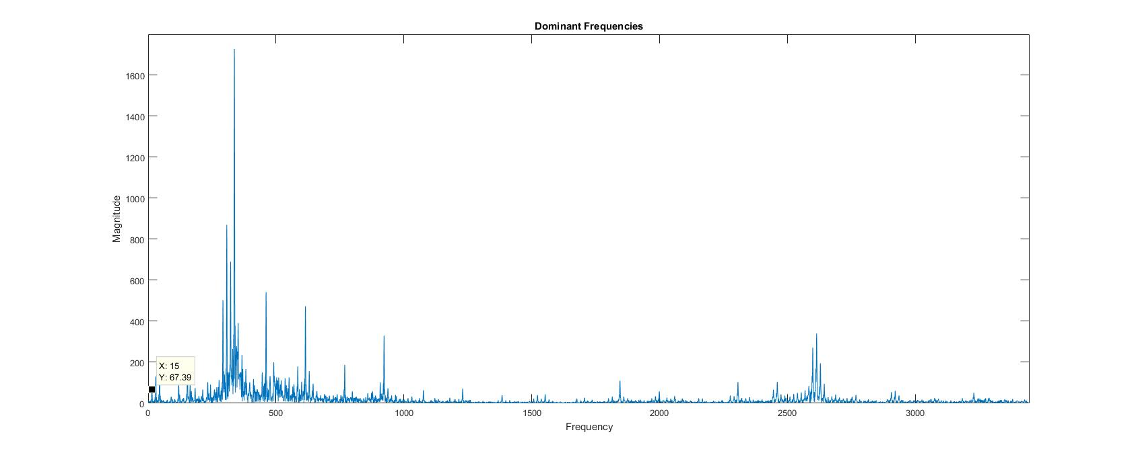

Figure : 15 Hz Peak

It is important to note that this is a relatively low peak compared to the rest of the peaks, indicating that the rotational of the main gears and blades is not a main source of vibration. The next peak, the RPM of the driver gear, is the RPM of the blades multiplied by the gear ratio, 175/17, equating to roughly 154 Hz, as shown below in Figure 25.

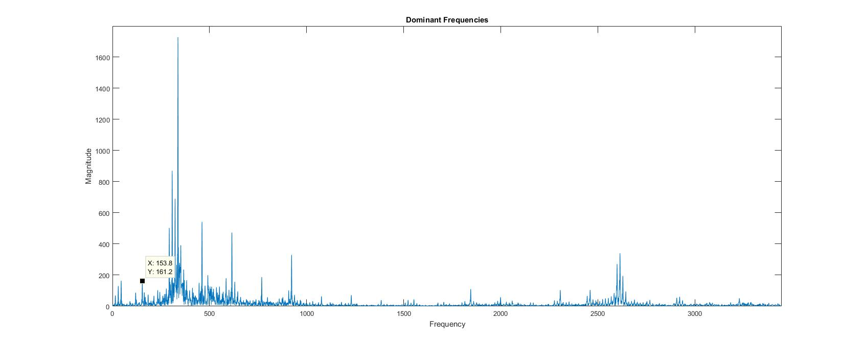

Figure : 153.8 Hz Peak

When the RPM of the motor and the RPM of the blades are added together and multiplied by a factor of 2 ([15+154]*2=338), the largest peak is obtained, as shown below in Figure 26.

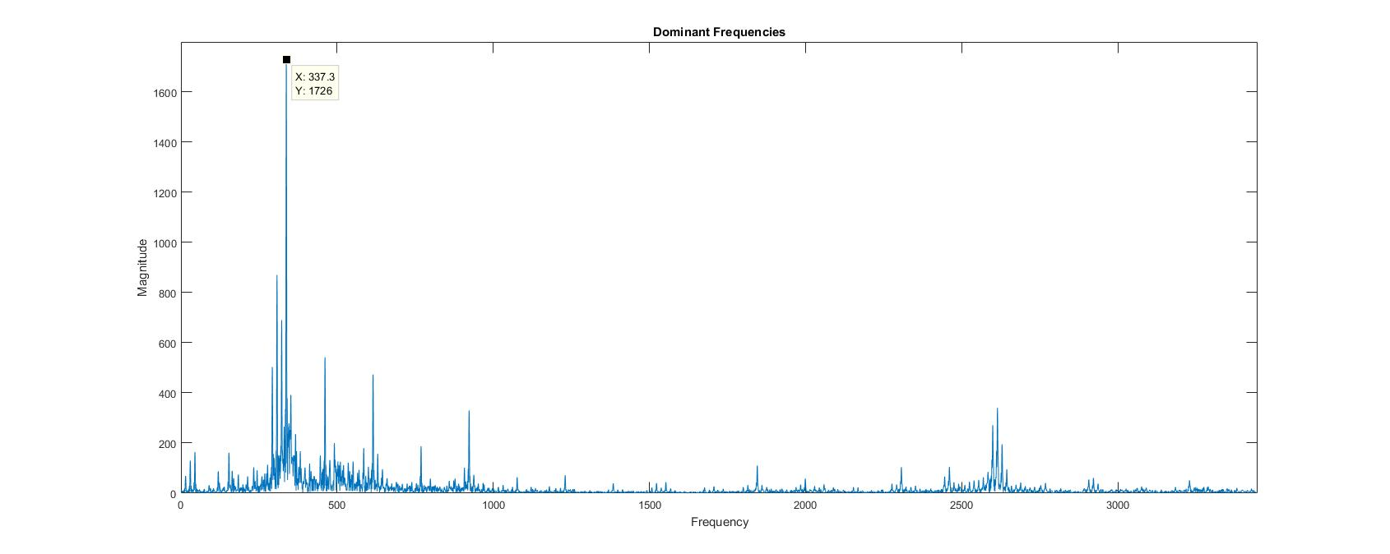

Figure : 337.3 Hz Peak

This is an interesting finding in the analysis of these peaks, as the largest peak would rather be expected to represent the RPM of the either the driver gear or blades. This finding was found in many other runs as well. This is due to the fact that one of the two main gears has the driver gear and other main gear meshing with it, so this gear is experiencing two different frequencies at the same time.

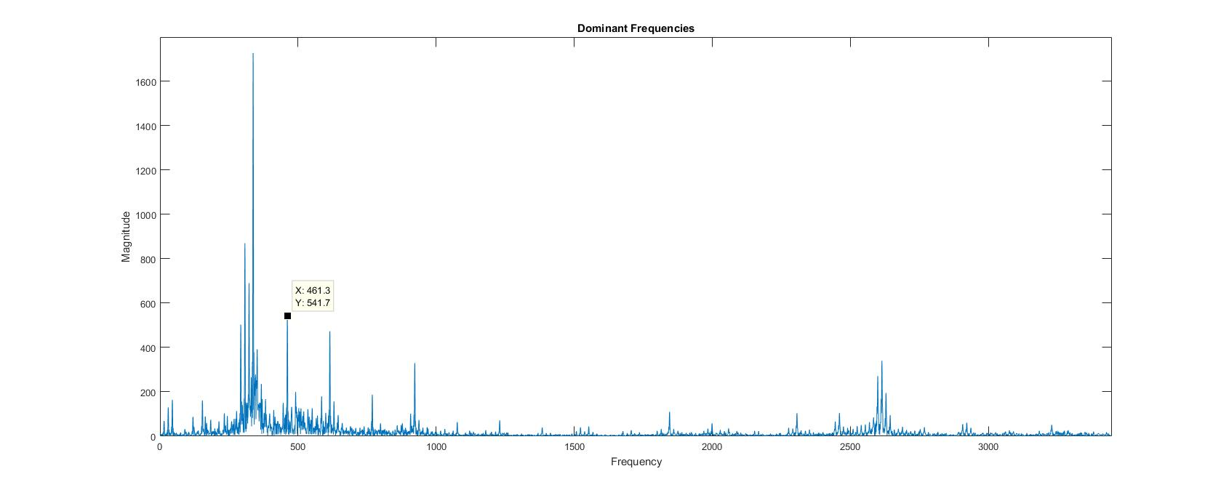

Figure : 461.3 Hz Peak

The next peak turns out to be a harmonic of the RPM of the driver gear, being a factor of 3 greater.

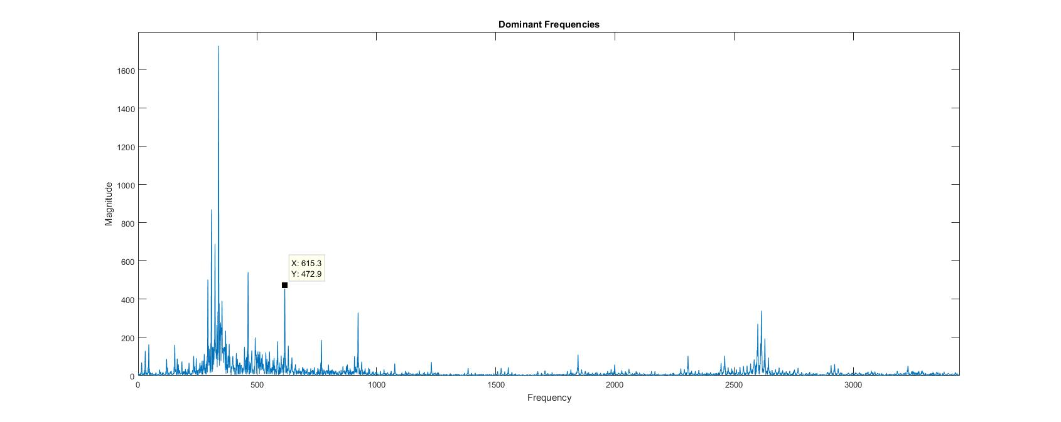

Figure : 615.3 Hz Peak

The next peak of 615.3 Hz is usually observed to be a harmonic two times larger than the most abundant peak. However, in this sample in particular, it is actually observed to be a harmonic four times larger than the RPM of the driver gear.

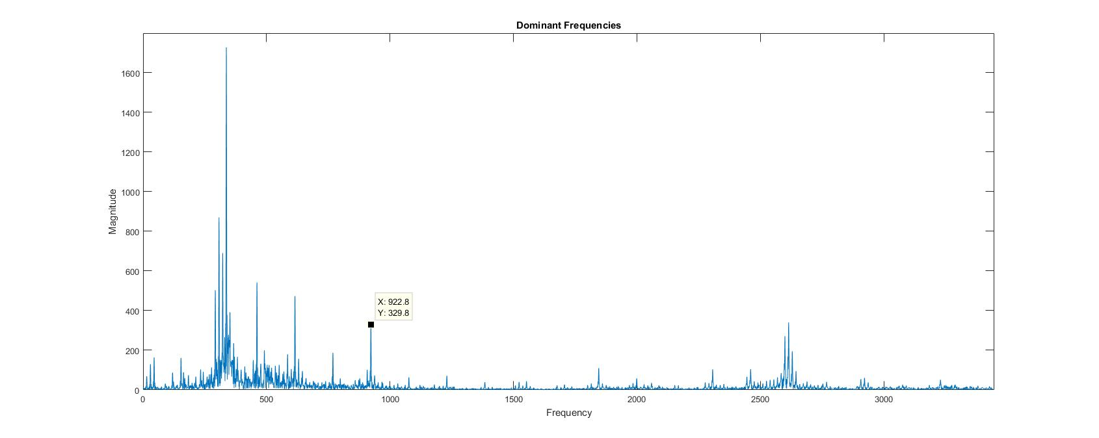

Figure : 922.8 Hz Peak

The next peak of 922.8 Hz is a harmonic twice the value of the 461.3 Hz peak, which previously mentioned was a harmonic of the driver gear RPM. This peak is therefore a harmonic six times larger than the RPM of the driver gear.

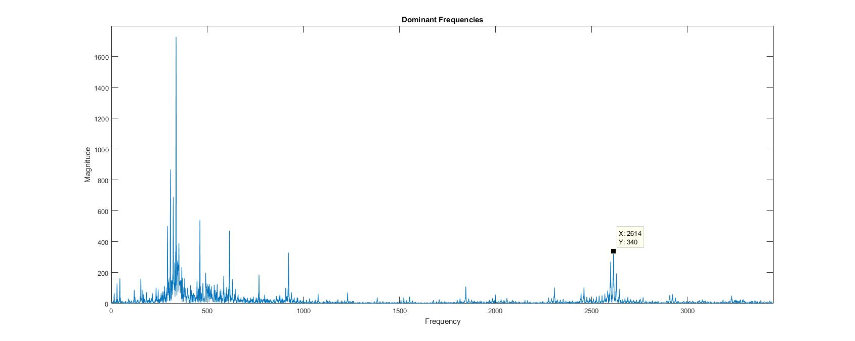

Figure : 2614 Hz Peak

The final significant peak found the Fourier transform represents the RPM of the driver multiplied by the number of teeth, or 15*175 = 2625 Hz, a number very close to this peak. This peak also represents the line witnessed in the spectrogram

# Discussion

## Engineering Standards

ISO/TC 108/SC 2 – Measurement and evaluation of mechanical vibration and shock as applied to machines vehicles and structures.

ISO/TC 108/SC 6 – Vibration and shock generating systems

## Impact Statement

There are environmental considerations to take into account for the different damping methods used on the K-MAX. All of the metallic parts of the stand are aluminum and thus can be recycled, but much of the vibrational damping materials like the rubber washers, the vibration pads, the vibration isolators, and drum symbol dampers cannot. Though they are not recyclable, some of the parts can be reused. The rubber washers can stay on the existing K-MAX or be used in any future projects that need to limit the transfer of vibration between the joints of a machine. The vibrational isolators may also be reused, as they are just bolted onto the stand and can be removed. The vibrational pads however were glued to the aluminum plates and removing them from the plate will most likely ruin their integrity. Besides the vibrational pads the different methods of vibration damping has a relatively low environmental impact as many of the parts can be reused for other projects or simply recycled.

## Future Work

Much can be done to further improve the vibrational damping of the K-MAX helicopter. Though a stand was created to test the vibration of the helicopter, vibration is the only thing it is currently able to test. The elimination of the old test stand, which influenced the vibration experienced, would make all of the tests done on the K-MAX more accurate. The main test done is to measure the lift that the blades are able to produce. To do this load cells were attached to the old stand to allow for the lift of the K-MAX to the measured, though the vibration during this test often skews the results. A future improvement to the stand would be to add load cells or a way to measure the lift that the K-MAX produces. This would give teams working on the K-MAX much more exact results than what is currently possible.

The blades and rotor of the K-MAX would also benefit from being balanced. The blades on the K-MAX have been calibrated, but both the rotors and the blades may be misaligned which is causing a lot of vibration. Balancing the blades will help each rotor of the helicopter provide an even amount of lift along the blades. This is going to be instrumental in damping the vibration of the K-MAX. In its current state, attached to a stand, the vibration coming from the blades and rotors can be visibly seen. Without the balancing being done the will most likely not be able to fly.

Another addition to that could be done to further eliminate the vibration experienced by the K-MAX is designing a permanent tuned mass damping system. The mass damping system that was covered in the scope of this report consisted of applying external masses onto the modal points of the K-MAX to reduce the vibration. This idea could be expanded on by using a part that is already in the helicopter like the motor or battery and attaching it to a mount that will use the weight of the part to counteract the vibration experienced within the helicopter. This addition would help with the flight of the K-MAX.

# Conclusion/Summary

Vibration, the oscillation about a point of equilibrium, is commonly found while operating any mechanical system as a result of the system’s dynamic characteristics. The existing dual rotor K-MAX helicopter developed by previous CCSU senior project groups produces large amounts of oscillations during testing. This means that some of the supplied motor torque is being transmitted in the form of mechanical vibration and is therefore adversely affecting the helicopter’s performance. Furthermore, if the vibration coming from the K-MAX is not controlled it may lead to premature wear and failure of flight critical components. Our team investigated potential methods of reducing the K-MAX vibration by applying tools acquired throughout our ME curriculum. The objective was to be able to more accurately characterize the behavior of such vibrations and study potential solutions for damping the most abundant frequencies. In addition, our findings provide direction for further works to be accomplished in the pursuit of a validating a flight ready vehicle.

In order to accurately obtain test data for analyzing the impact of vibration damping techniques, it was important that the original test stand was improved. The original test stand containing load cells was very unstable and potentially impacted the vibrations coming from the K-MAX. Therefore, our team developed a new test stand with the intention of isolating the vibration signal produced. Each design iteration of the vibration isolating test stand was completed inside of Siemens NX. Once the design was finalized, parts were procured using the most cost effective route and manufactured using readily available equipment. The newly created test stand was then implemented during the testing phase. Results were gathered using the accelerometer for both test stands and compared using statistical analysis. It was found that the vibration isolating test stand was successful in performing its intended function. Our test stand produced less vibrations than the original test stand developed in previous semesters. Therefore, it can be stated that the experimental data gathered from the new test stand provides a more accurate representation of the actual vibration signal coming from the K-MAX.

In addition to developing a new test stand, the initiative was taken to analyze potential methods for damping the oscillations felt by the K-MAX. One of the techniques adopted was to create a mass damping system that is based on the fundamentals of a mass, spring and damper system. It is understood that a concentrated mass applied to certain critical locations on the K-MAX could potentially reduce the vibration output. In order to find those critical locations, modal analysis was applied to the CAD models of each component. Based on the geometry and the material type, important characteristics were determined from the modal analysis results. These results provided the mode shapes of the structure, common natural frequencies as well as the best locations to apply the mass damping system. With that knowledge, damping gels and magnets were applied to the physical K-MAX in these locations during the execution of the test procedure. However, accelerometer readings taken for multiple test runs with and without the weight and gels indicates that the mass damping system did not have a significant effect on the amount of oscillations produced. This may be because the mass of the gel and magnet was not enough to have a large enough effect on the vibration experienced within the K-MAX. The gel masses also were distributed along the circular area of the gel masses when a more concentrated mass at the modal point may have had a greater impact. In the future, this method can be fine-tuned to come up with a permanent design that has a greater effect on reducing the vibrations.

Another method for reducing the vibrational signal that was analyzed was by varying the pitch angle of the blades. It was hypothesized that the blade pitch angle has a significant effect on the amount of vibrations produced by the K-MAX. In the design of experiments, seven different pitch angles were tested to be able to understand the impact of such a feature. Based on the analytical results of these test variables, it was determined that some pitch angles helped to reduce vibrations while others had no significant effects. It can be concluded that the pitch angles of 12 and 14.5 degrees have the greatest impact on the amount of vibrations felt by the K-MAX of the range of pitch angles examined. Conversely, the pitch angles of 9, 9.5, 12.5 and 14 degrees were determined to not be the cause of additional vibrations in the structure.

Some general characteristics of the K-MAX vibrational profile was resolved through analysis and manipulation of the experimental data obtained throughout the test procedure. The data provided by the accelerometer can be applied to a graph of frequency vs. amplitude. When the data is plotted in this form, certain peaks are can be visually identified to be at much greater amplitudes than others. The various operating frequencies of the K-MAX components contained various sizes of peaks at those locations on the graph. These peaks were able to be identified and are considered to be significant to understanding the important features that impact the vibration of the structure.

The vibration damping project was planned and tracked using Microsoft Project. Each task was executed within the required timeframe and predetermined budget. All project deliverables were completed on time. The overall vibration in the model K-MAX helicopter was ultimately able to be reduced with the use of the vibration isolating test stand. Essential data was also collected that could be expanded upon in the future which will allow the K-MAX to one day actually be able to fly.

# Bibliography

Amer, Kenneth B., and James R. Neff. "Vertical-Plane Pendulum Absorbers for Minimizing Helicopter Vibratory Loads." *Journal of the American Helicopter Society* 19.4 (1974): 44-48. Web.

Anusonti-Inthra, Phuriwat, and Farhan Gandhi. "Optimal control of helicopter vibration through cyclic variations in blade root stiffness." *Smart Materials and Structures* 10.1 (2001): 86-95. Web.

Cloutier, Dave, and Peter Avitabile. *Shaker/Stinger Effects on Measured Frequency Response Functions*. Rep. Lowell: Structural Dynamics and Acoustic Systems Laboratory U of Massachusetts Lowell, n.d. Print.

De Silva, Clarence W., ed. *Vibration Damping, Control, and Design*. Boca Raton: Taylor & Francis, 2007. Print.

"Digiducer USB Digital Accelerometer." *The Modal Shop, Inc.* PCB Group, Inc., 2017. Web. 08 May 2017.

Legrand, Louis Francois, and Charles Henri Tresch. Vinration Damping Helicopter Rotor Support. Sud Aviat Soc Nationale De Con, assignee. Patent US3502290 A. 24 Mar. 1970. Web.

Livshitz, Stanley L., and Robert Alan Mayo. Self-Balancing Centrifuge Method and Apparatus. Technicon Instr, assignee. Patent US3692236A. 19 Sept. 1972. Web.

Mard, Kenneth Chris, Paul Warren Vonhardenberg, Sylvester John Washburn, and Edward Lavoie. Vibration Absorber and Use Thereof in a Helicopter. United Technologies Corporation, assignee. Patent EP0008585 A1. 05 Mar. 1980. Web.

"Miniture Load Cell -iLoad Mini." *LoadstarSensors.com*. Loadstar Sensors, 2017. Web. 08 May 2017.

Nagasaka, Imao, Yukio Ishida, Takayuki Koyama, and Naoki Fujimatsu. "Vibration Suppression of a Helicopter Fuselage by Pendulum Absorbers: Rigid-Body Blades with Aerodynamic Excitation Force." *Journal of System Design and Dynamics* 2.6 (2008): 1230-238. Web.

Robbins, Mark. "Vibration Identification & Minimization." *Rotor & Wing*. Rotor and Wing International, 01 Nov. 2010. Web. 01 Apr. 2017. <http://www.rotorandwing.com/2010/11/01/vibration-identification-minimization/>.

Rutkowski, Michael J. "Assessment of Rotor-Fuselage Coupling on Vibration Predictions Using a Simple Finite Element Model." *Journal of the American Helicopter Society* 28.3 (1983): 20-25. Web.

"Software." *Digiducer*. Digiducer Inc., 2017. Web. 08 May 2017.

"The Fundamentals of Modal Testing." *Application Note 243-3* (2000): n. pag. *Agilent Technologies*. Web.

"University Program." *The Modal Shop, Inc.* PCB Group, Inc., 2017. Web. 08 May 2017.

# Appendix

**Test Runs of K-MAX under different Variables**

* Run 1: Pitch Angle 12ᵒ, Without Gel Mass, Without Vibration Isolating Stand

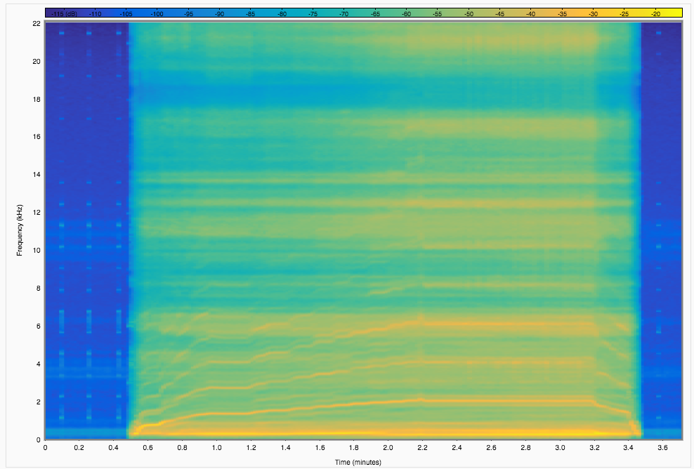

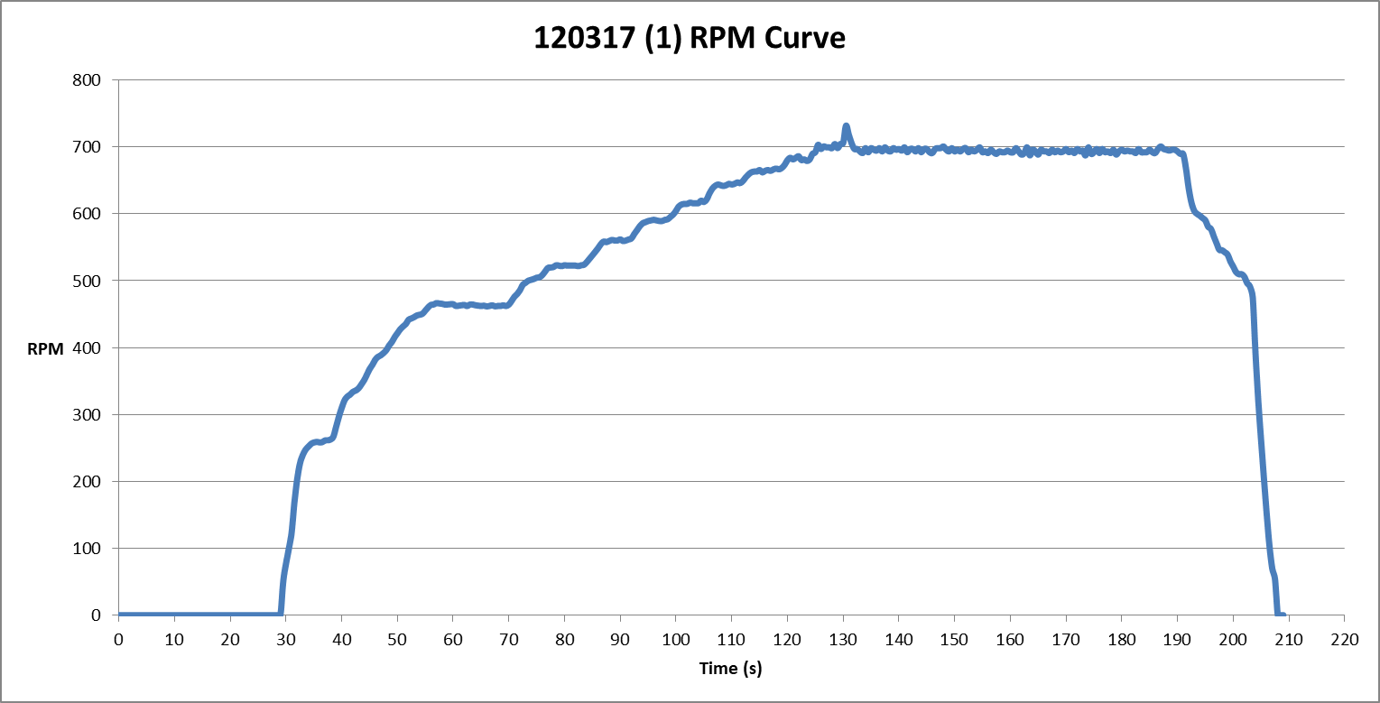

* Run 2: Pitch Angle 12ᵒ, With Gel Mass, Without Vibration Isolating Stand

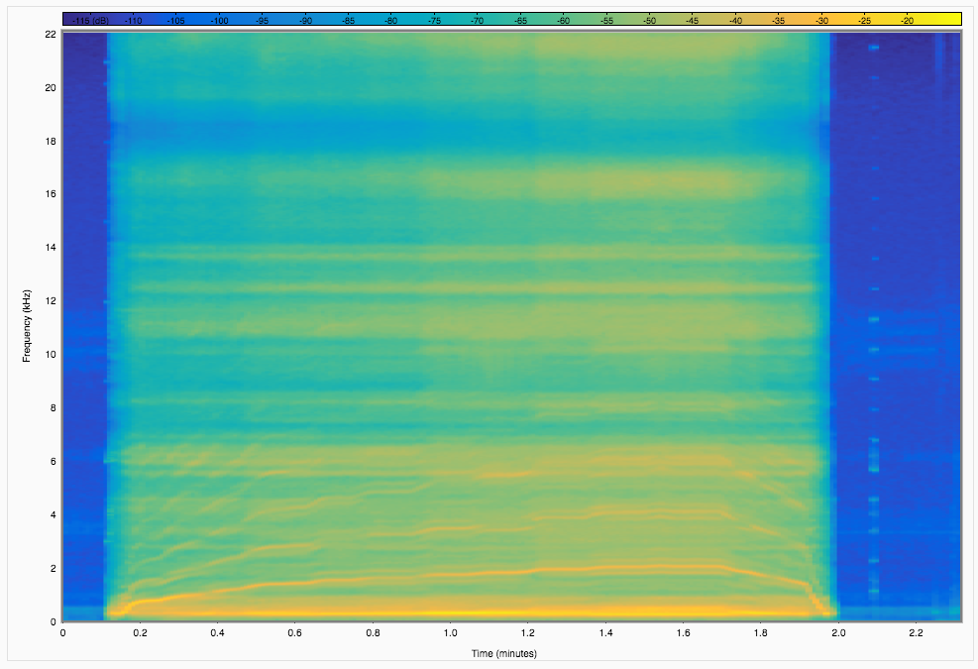

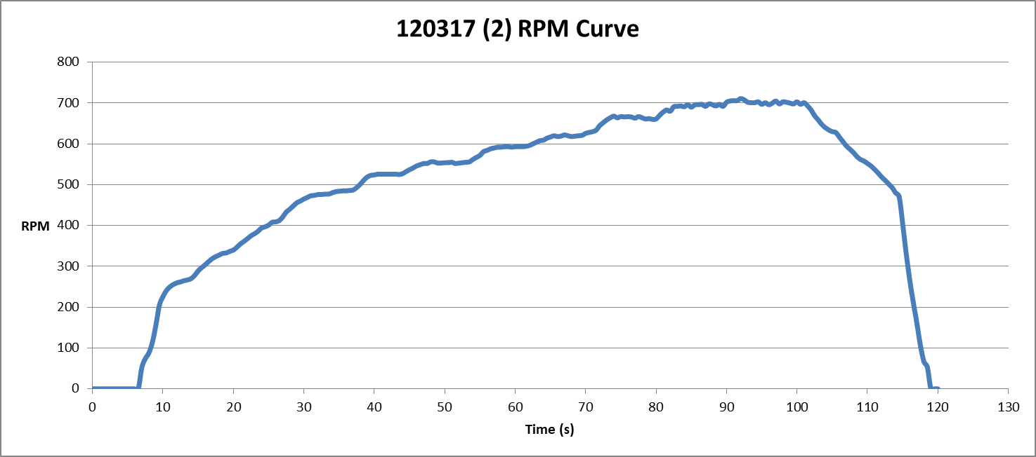

* Run 3: Pitch Angle 9ᵒ, With Gel Mass, Without Vibration Isolating Stand

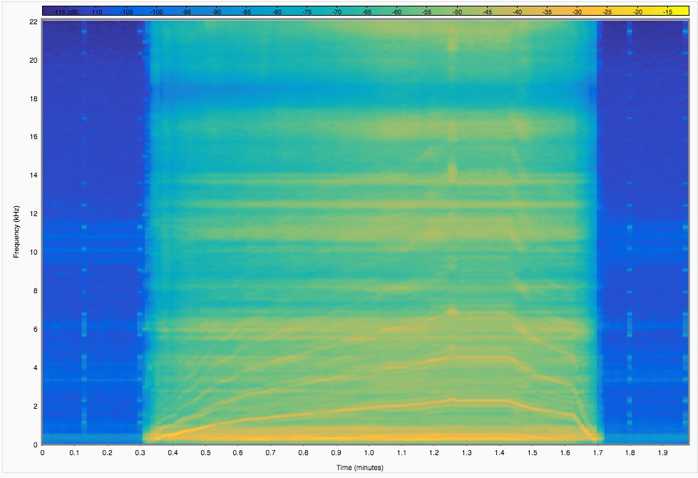

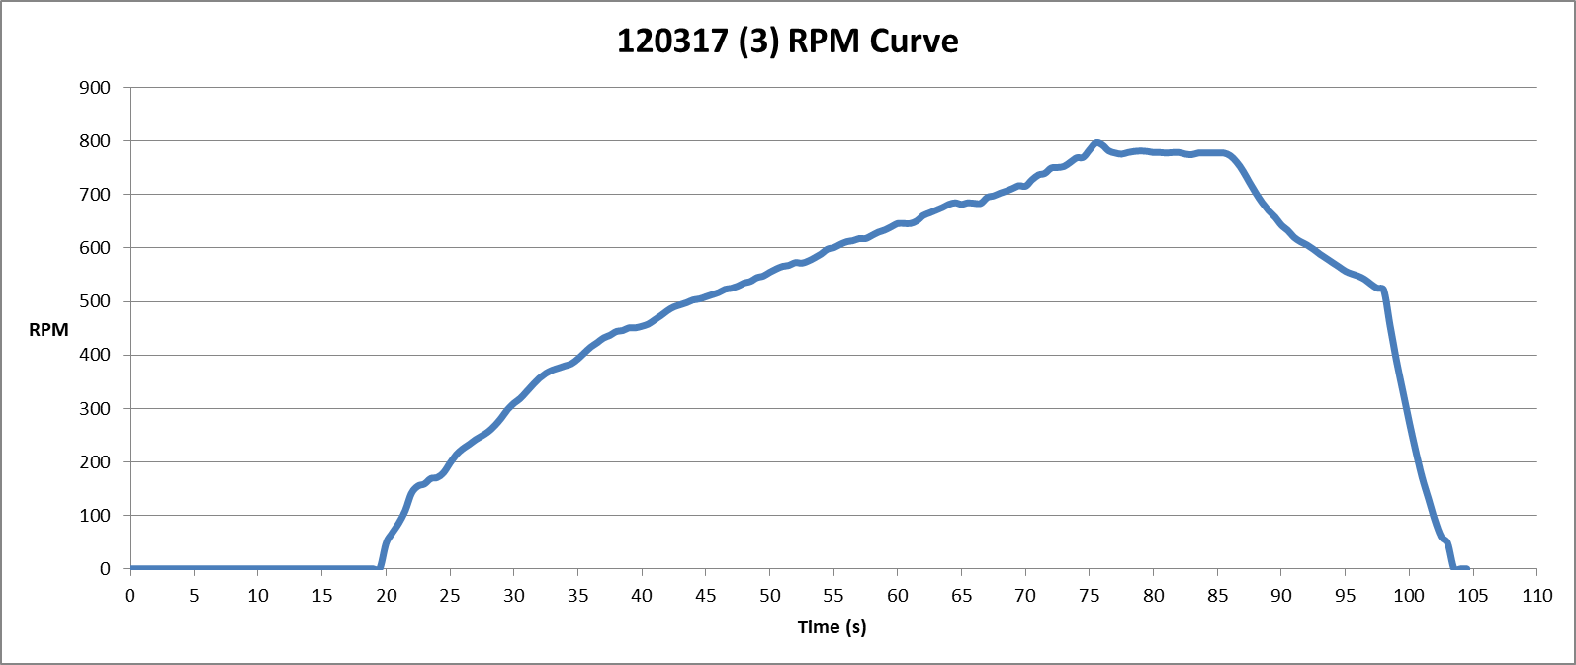

* Run 4: Pitch Angle 9ᵒ, Without Gel Mass, Without Vibration Isolating Stand

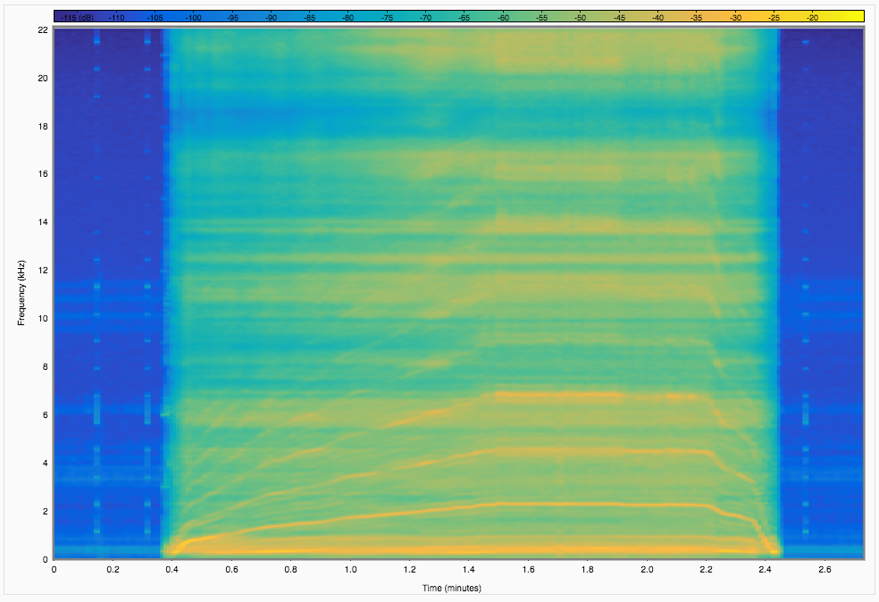

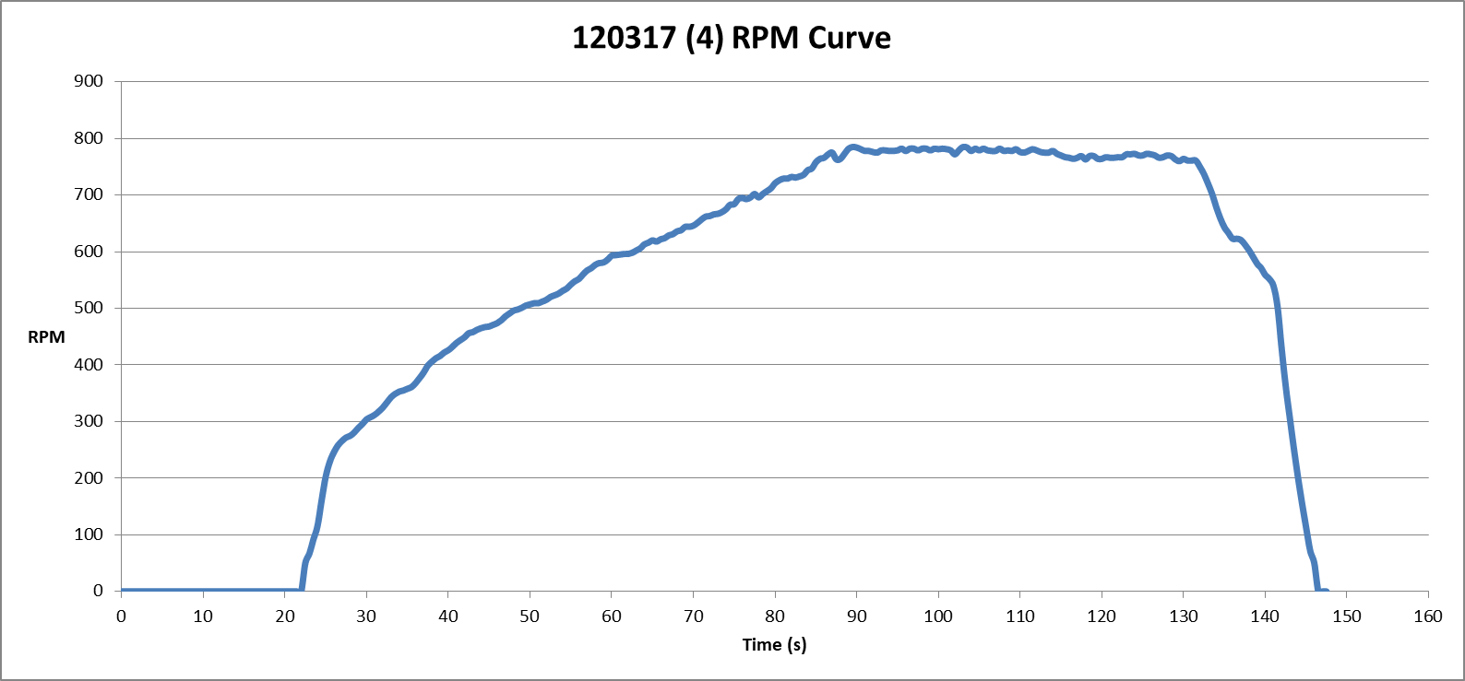

* Run 5: Pitch Angle 14.5ᵒ, Without Gel Mass, Without Vibration Isolating Stand

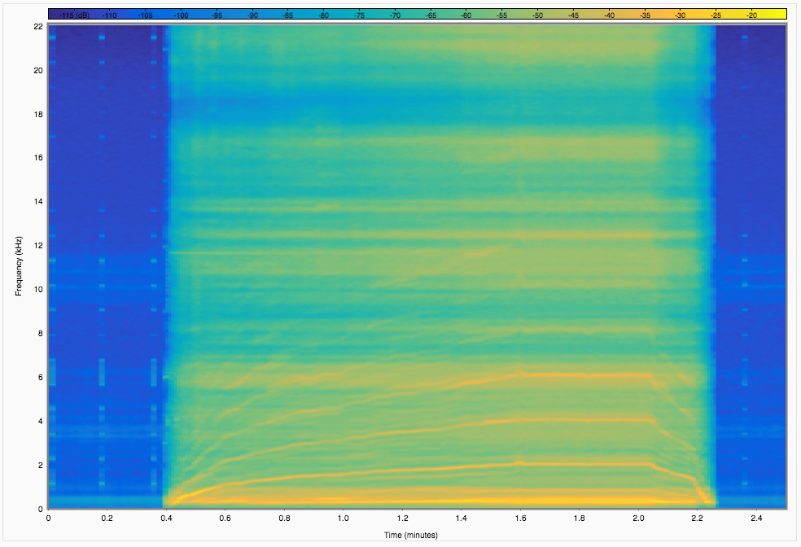

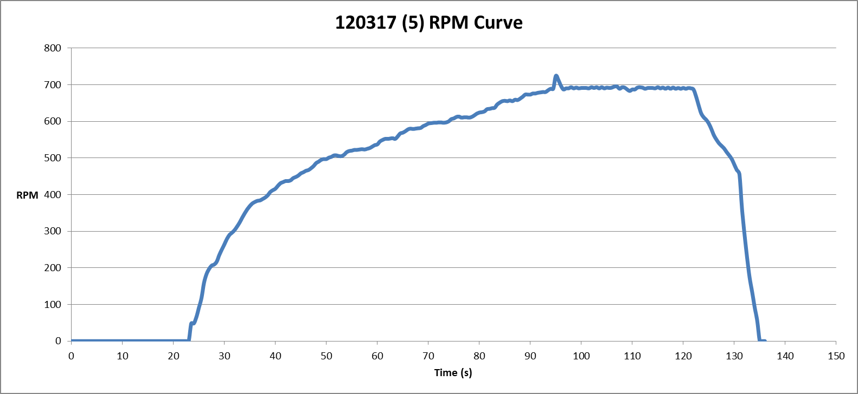

* Run 6: Pitch Angle 14.5ᵒ, With Gel Mass, Without Vibration Isolating Stand

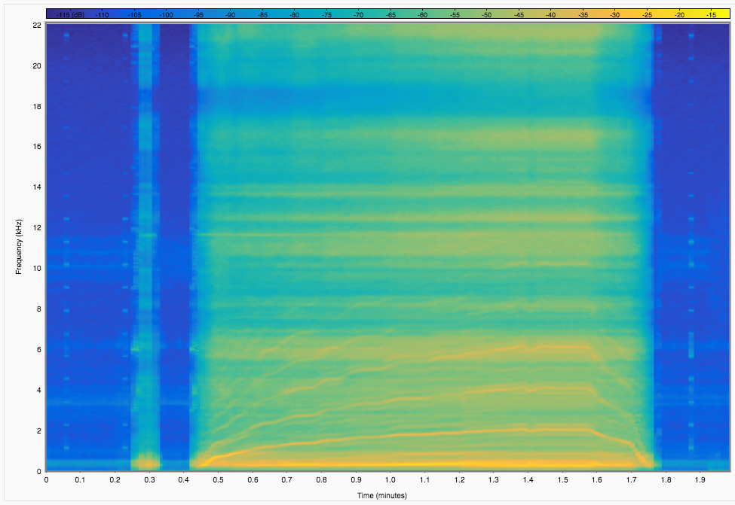

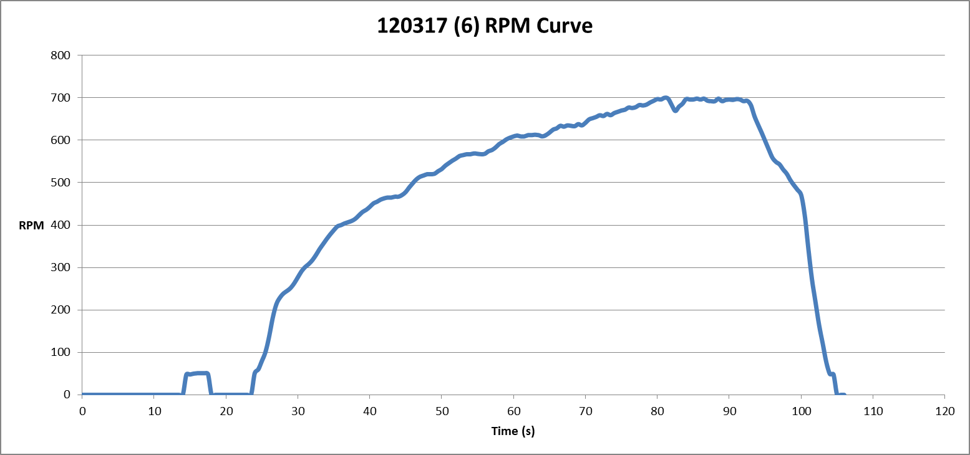

* Run 7: Pitch Angle 15ᵒ, With Gel Mass, Without Vibration Isolating Stand

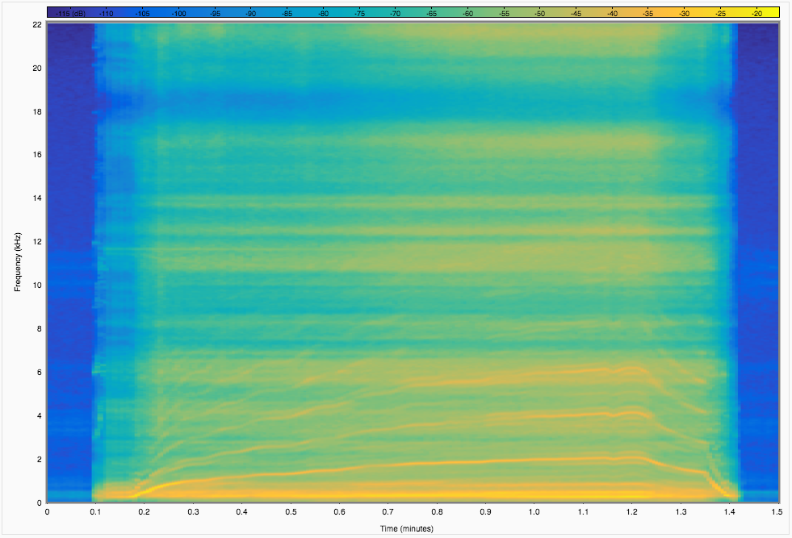

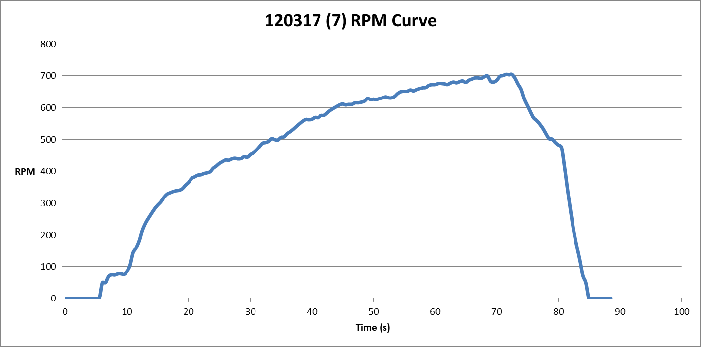

* Run 8: Pitch Angle 14ᵒ, With Gel Mass, With Vibration Isolating Stand

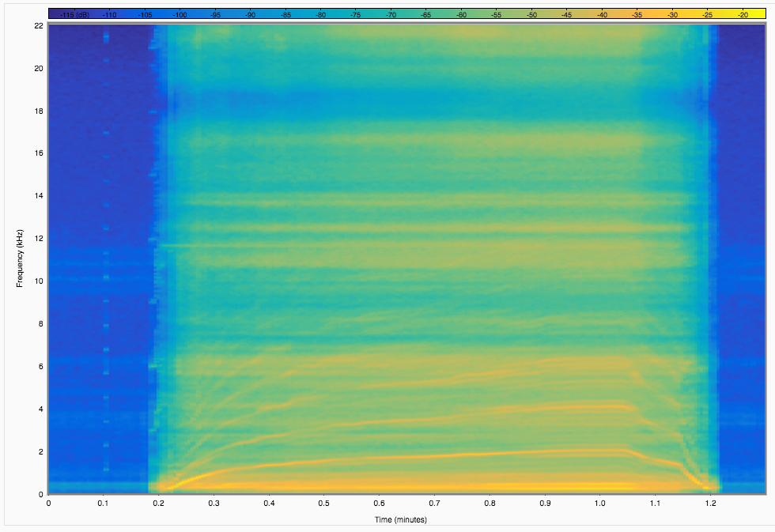

* Run 9: Pitch Angle 12.5ᵒ, With Gel Mass, With Vibration Isolating Stand

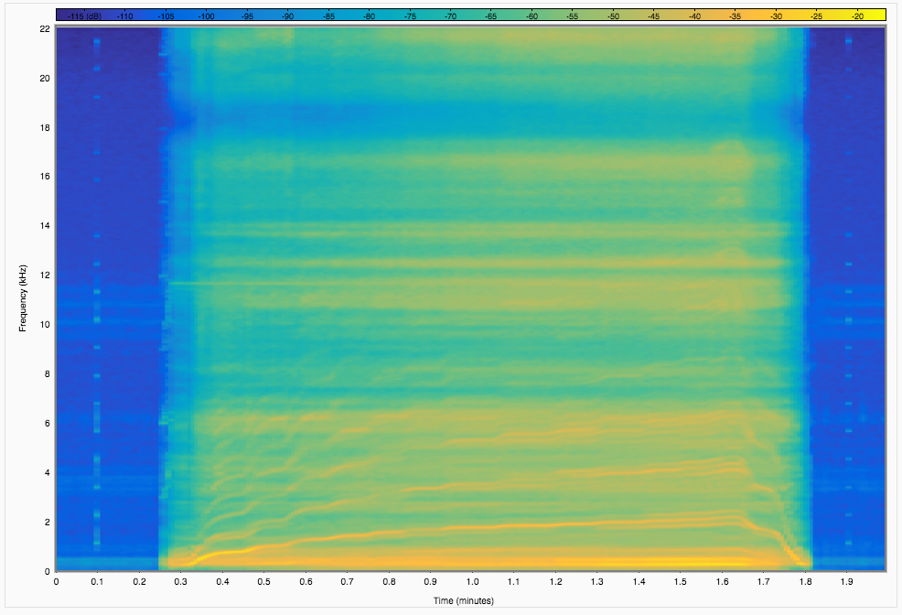

* Run 10: Pitch Angle 12.5ᵒ, With Gel Mass, With Vibration Isolating Stand

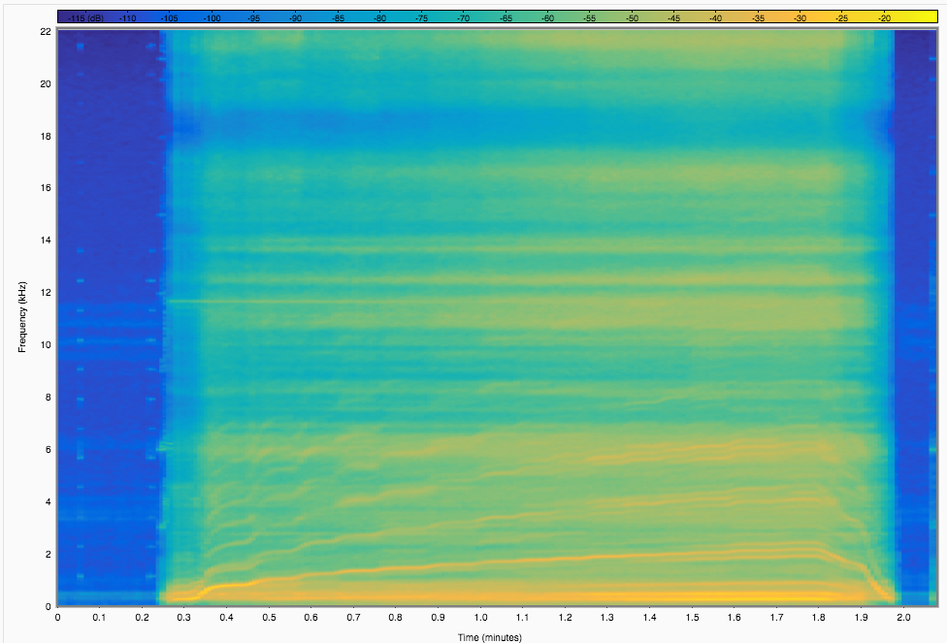

* Run 11: Pitch Angle 9.5ᵒ, With Gel Mass, With Vibration Isolating Stand

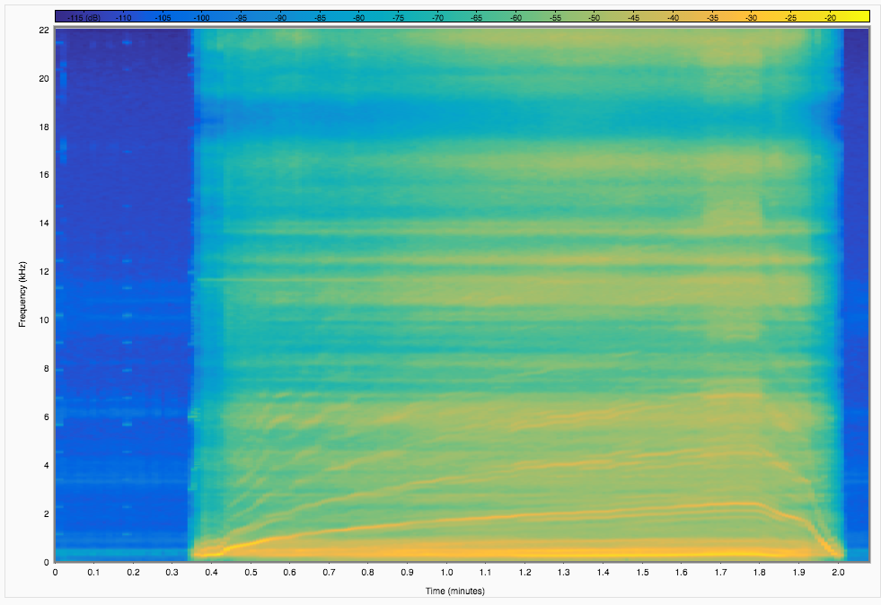

* Run 12: Pitch Angle 9.5ᵒ, With Gel Mass, With Vibration Isolating Stand

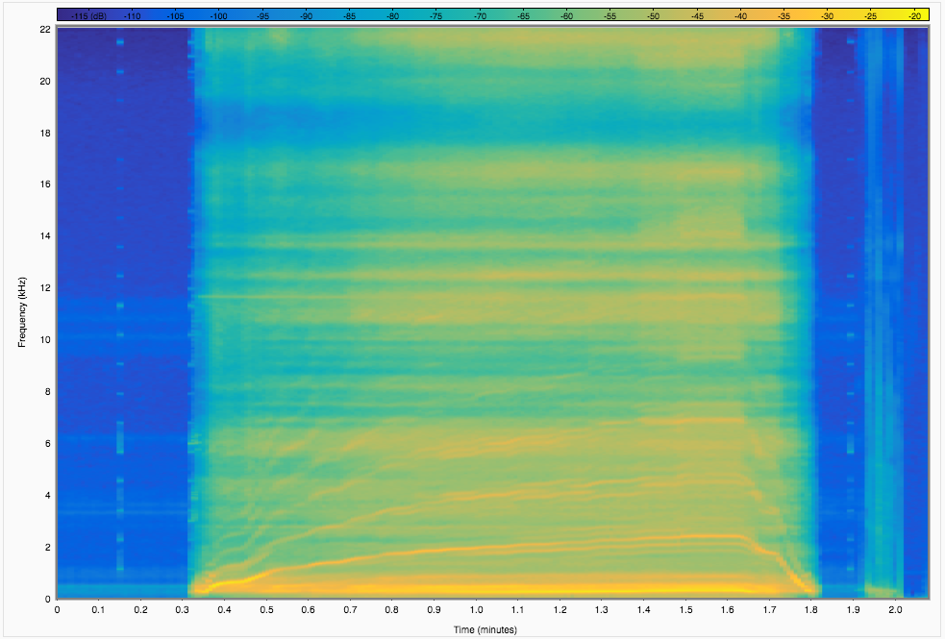

* Run 13: Pitch Angle 9.5ᵒ, With Gel Mass, Without Vibration Isolating Stand

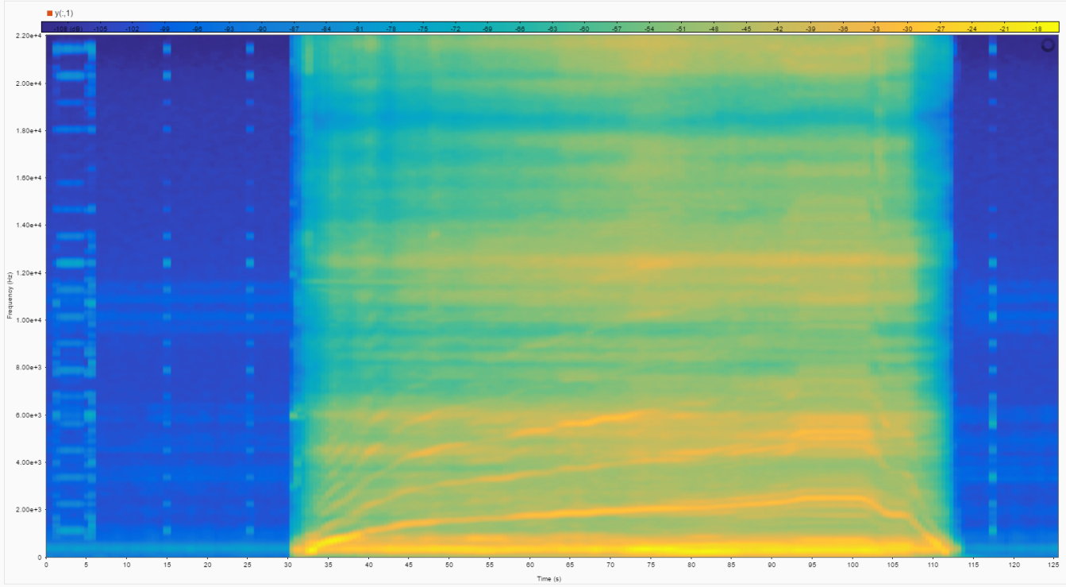

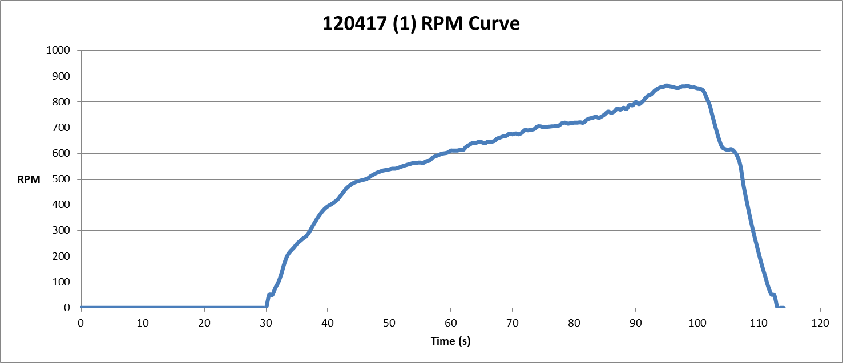

* Run 14: Pitch Angle 9.5ᵒ, With Gel Mass, Without Vibration Isolating Stand

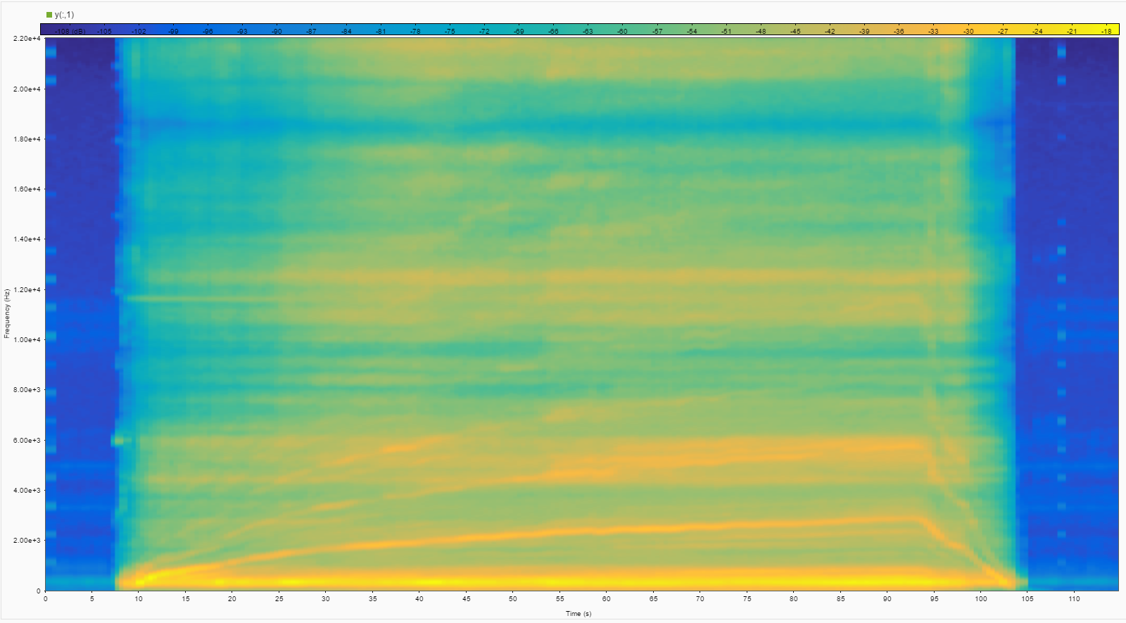

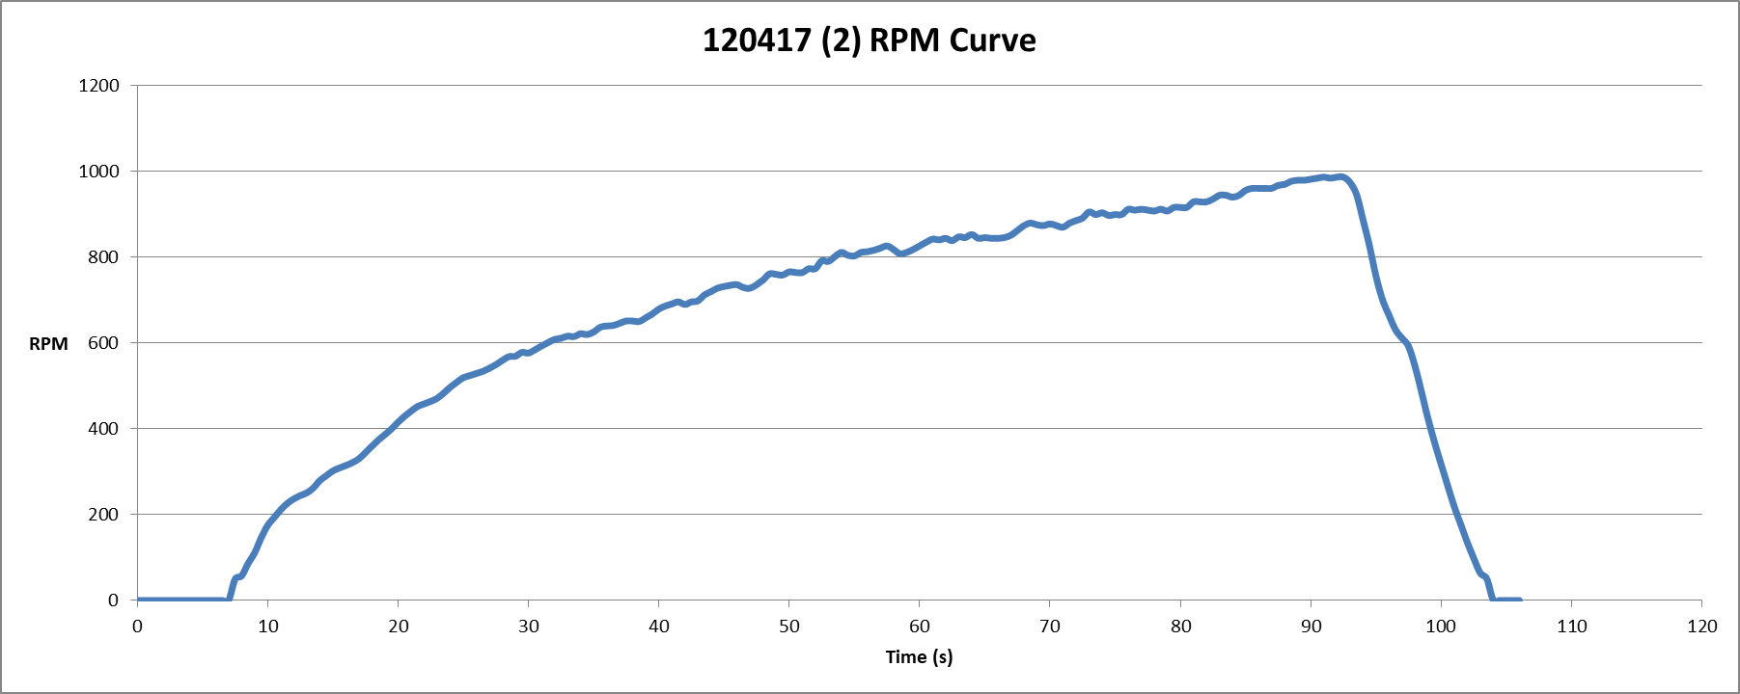

* Run 15: Pitch Angle 12.5ᵒ, With Gel Mass, Without Vibration Isolating Stand

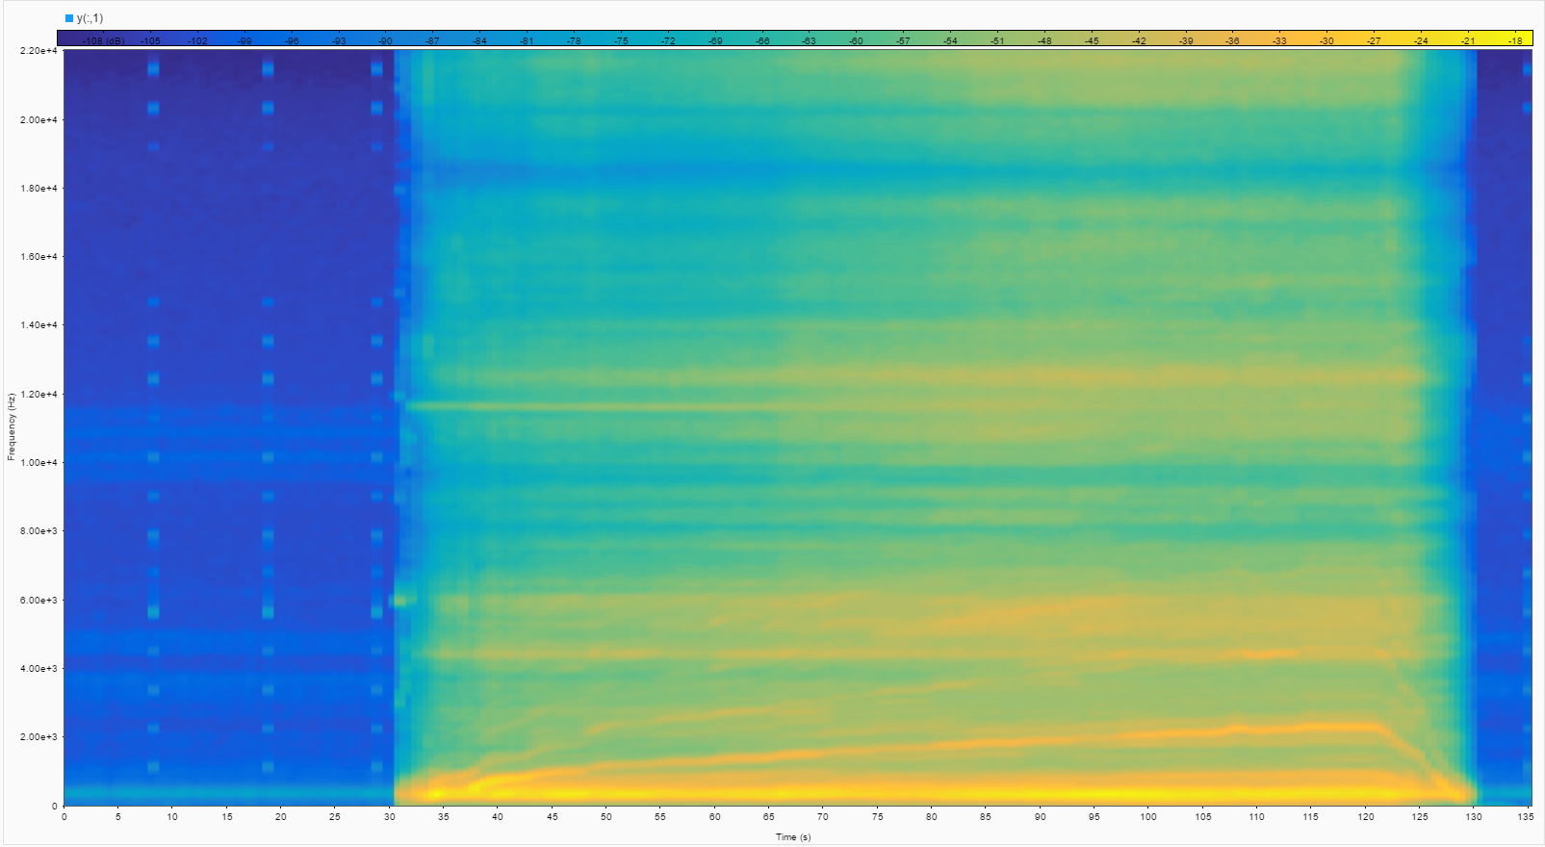

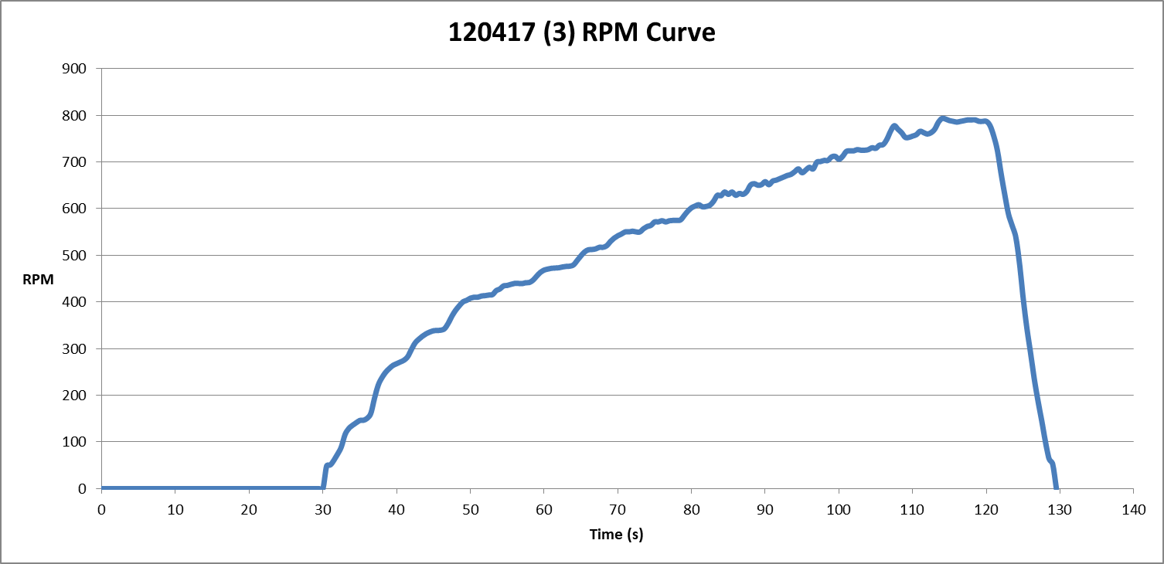

* Run 16: Pitch Angle 12.5ᵒ, With Gel Mass, Without Vibration Isolating Stand

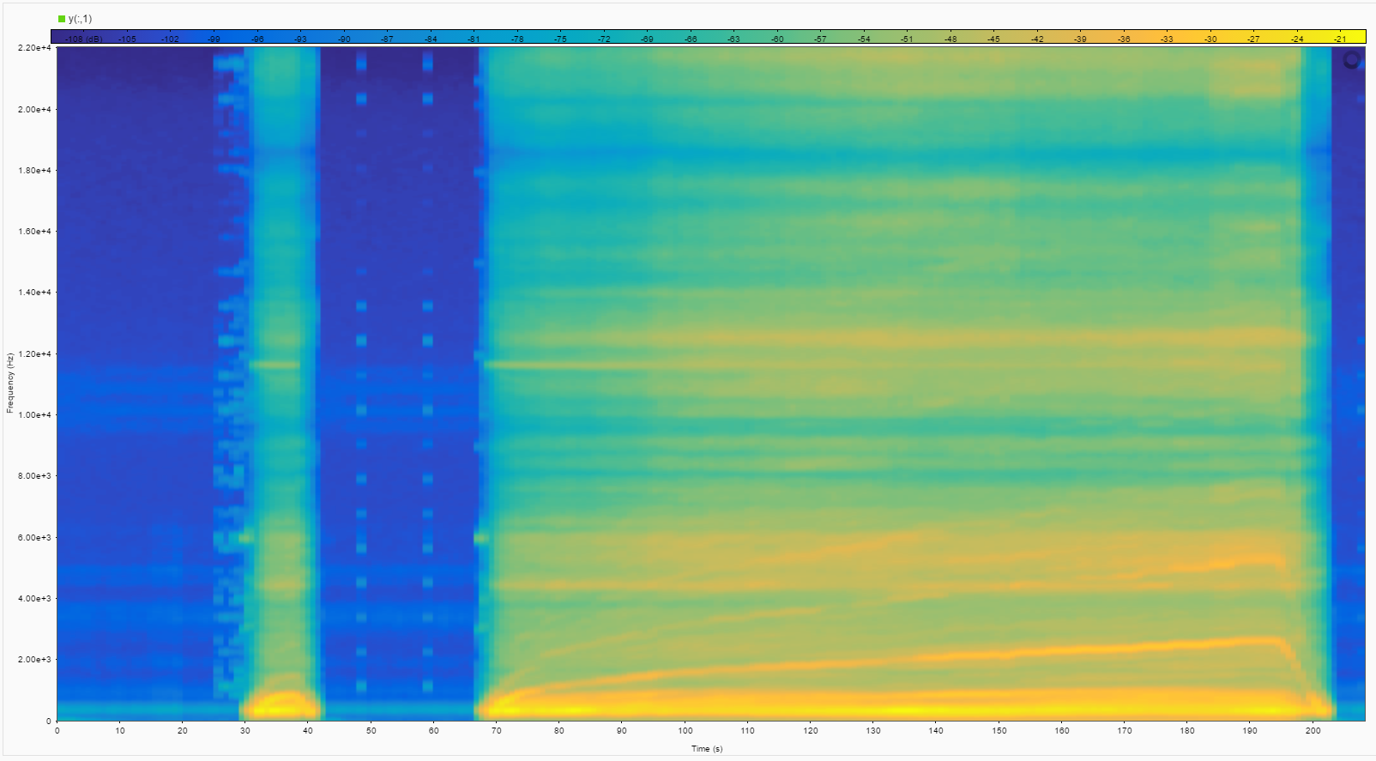

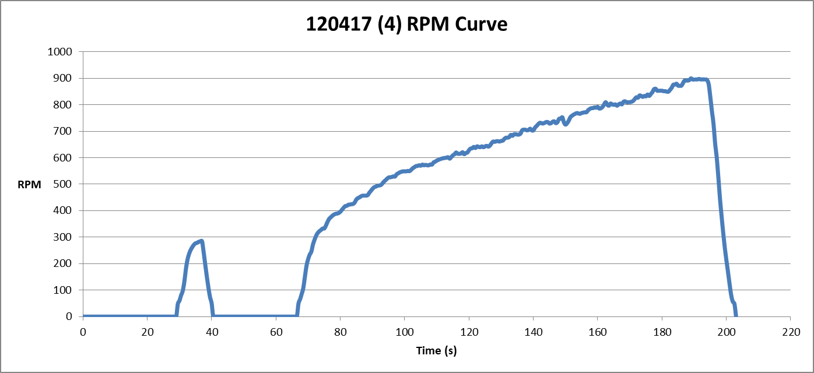

* Run 17: Pitch Angle 12.5ᵒ, With Gel Mass, Without Vibration Isolating Stand

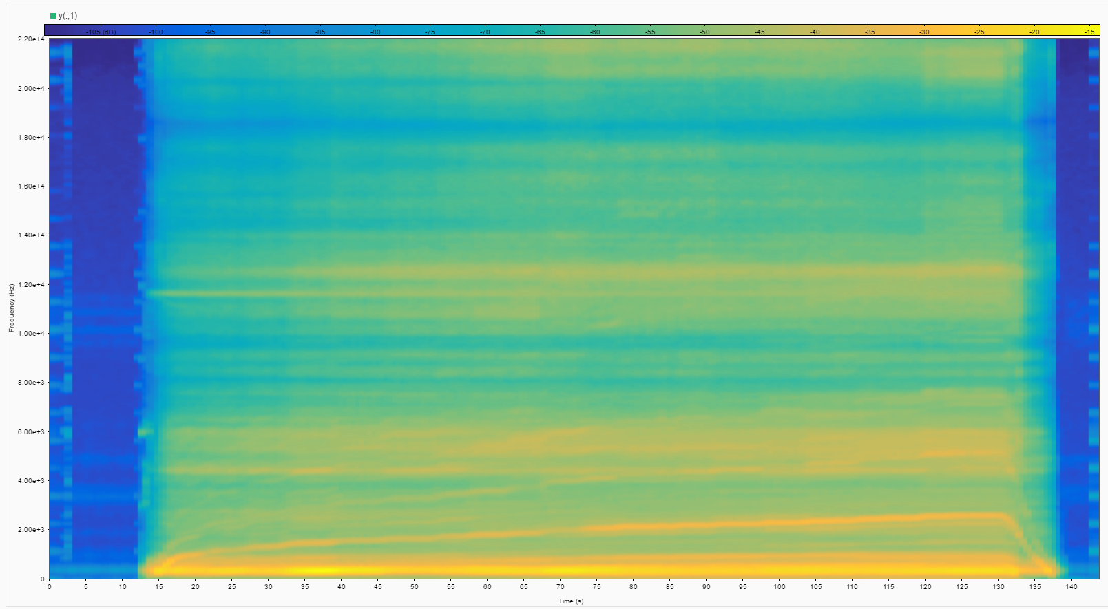

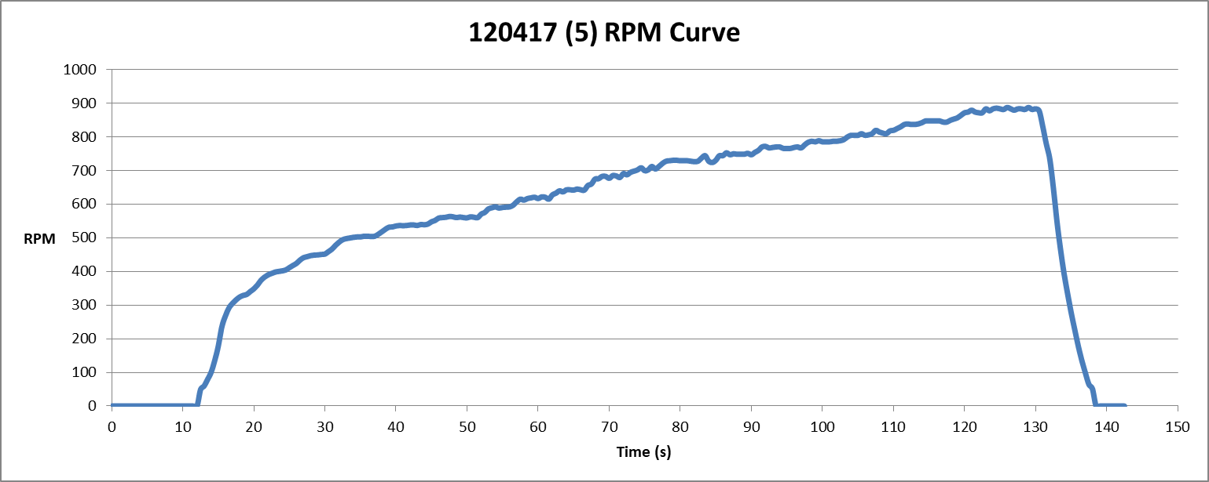

* Run 18: Pitch Angle 14ᵒ, With Gel Mass, Without Vibration Isolating Stand

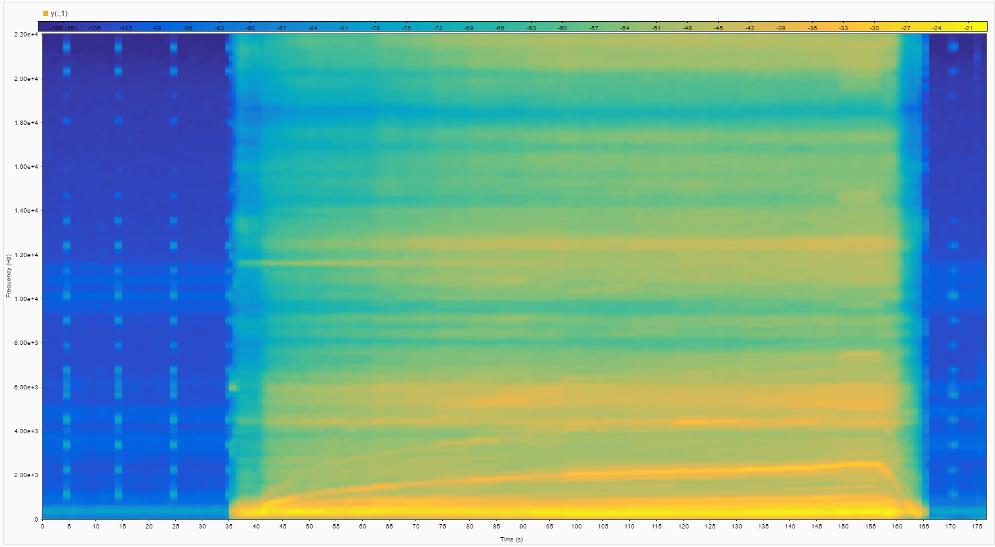

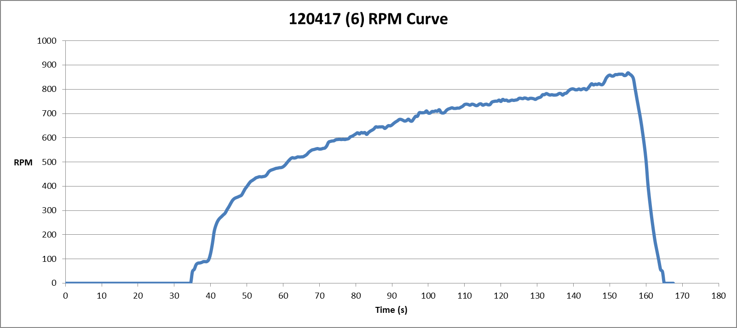

* Run 19: Pitch Angle 14ᵒ, With Gel Mass, Without Vibration Isolating Stand

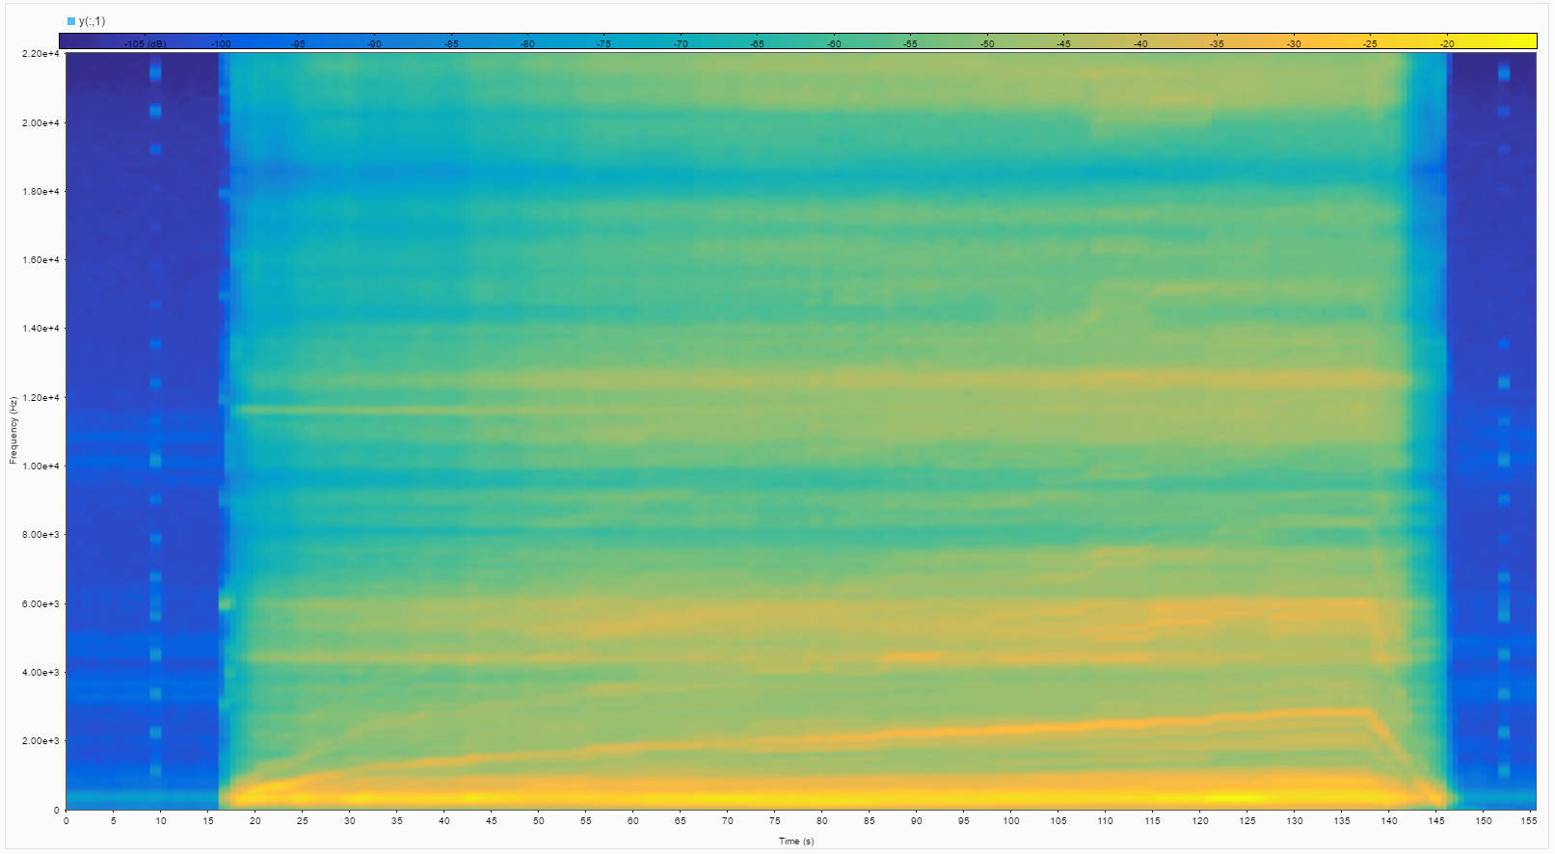

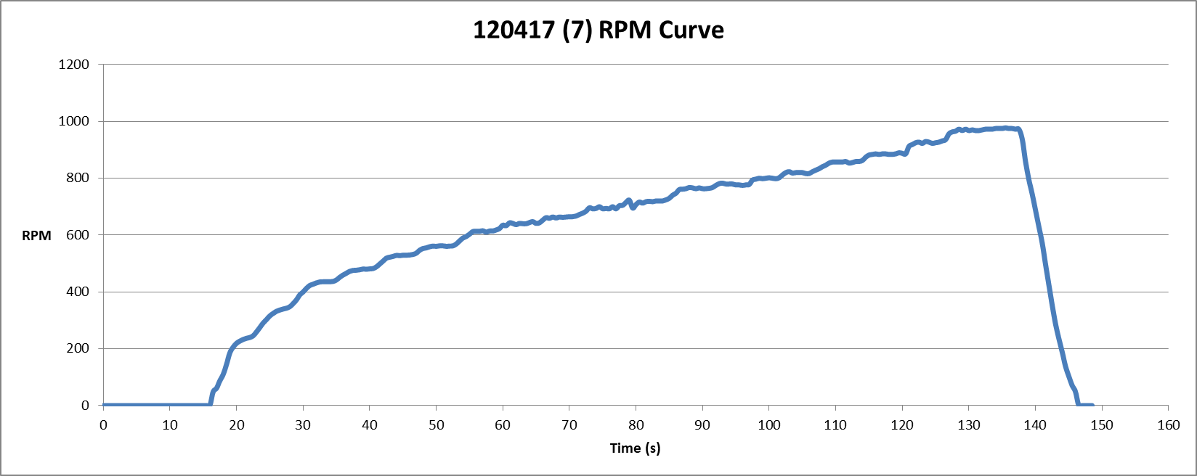

* Run 20: Pitch Angle 14.5ᵒ, With Gel Mass, Without Vibration Isolating Stand

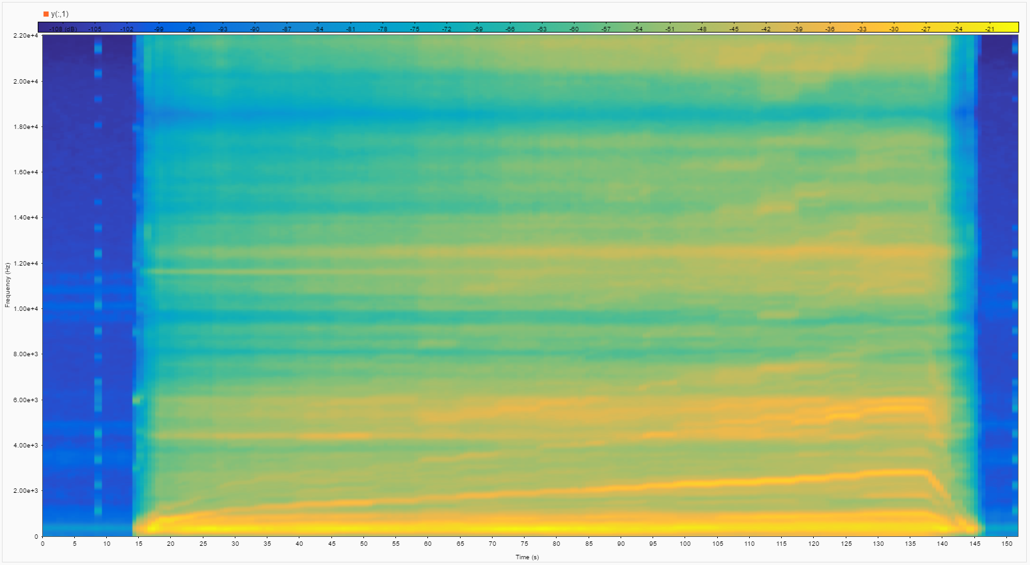

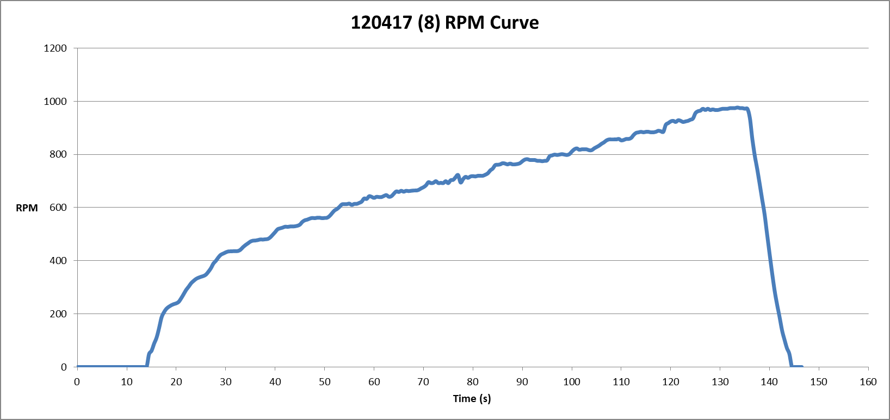

* Run 21: Pitch Angle 14.5ᵒ, With Gel Mass, Without Vibration Isolating Stand

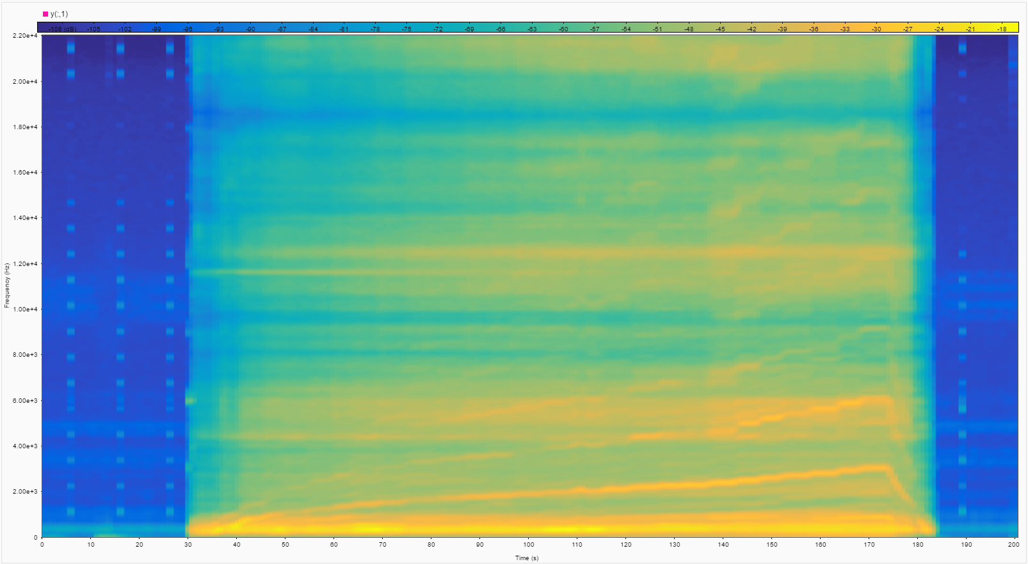

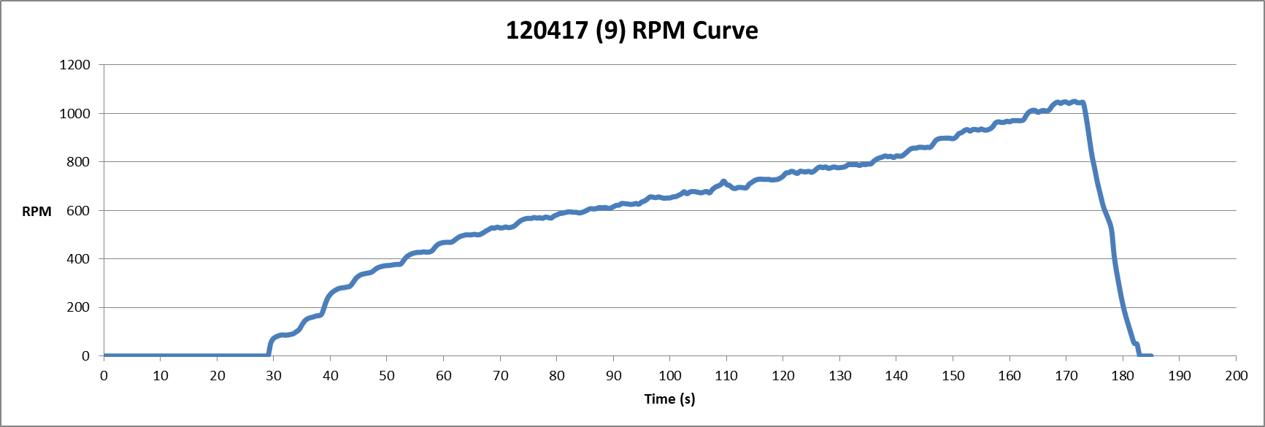

* Run 22: Pitch Angle 14.5ᵒ, With Gel Mass, Without Vibration Isolating Stand

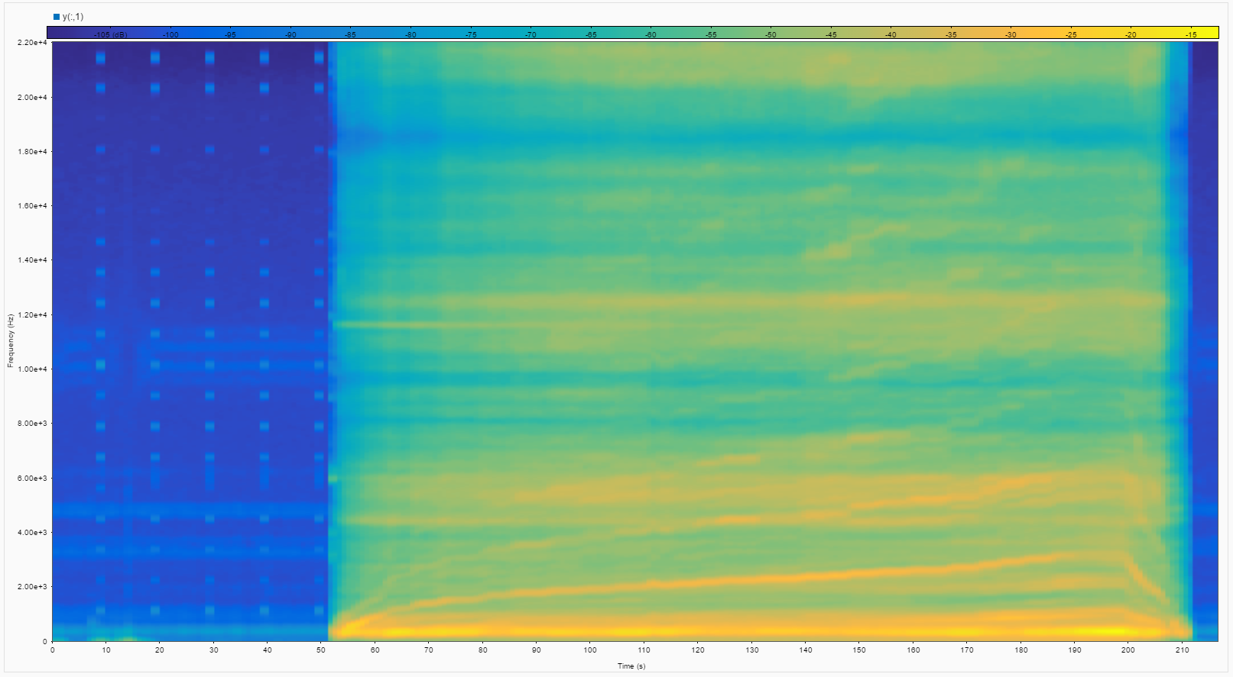

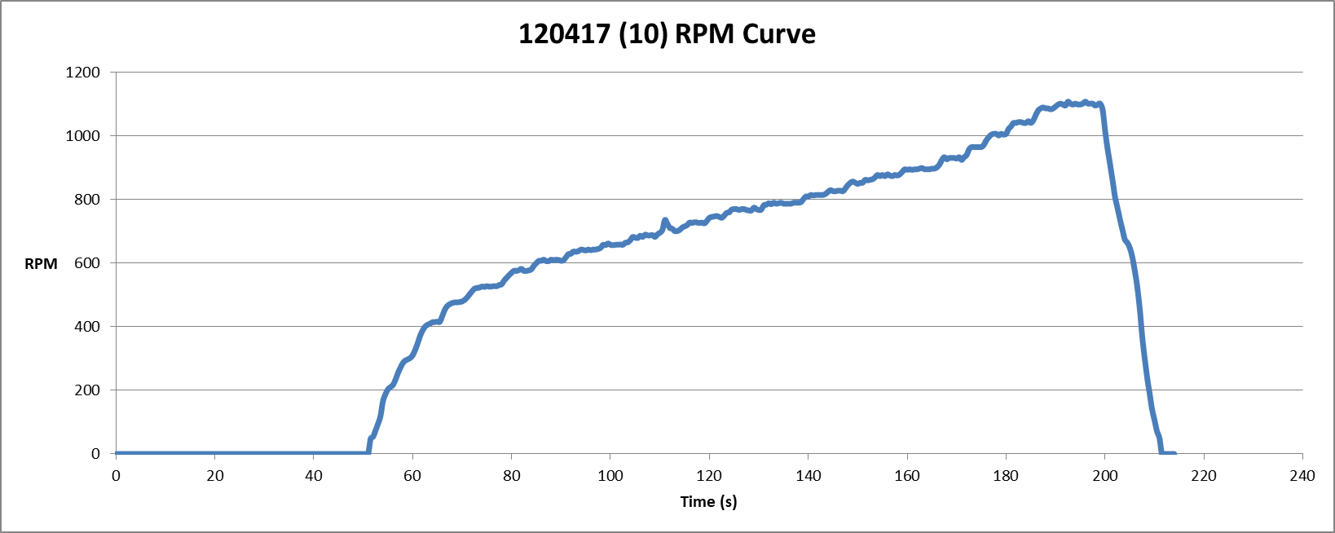

* Run 23: Pitch Angle 14.5ᵒ, With Gel Mass, Without Vibration Isolating Stand

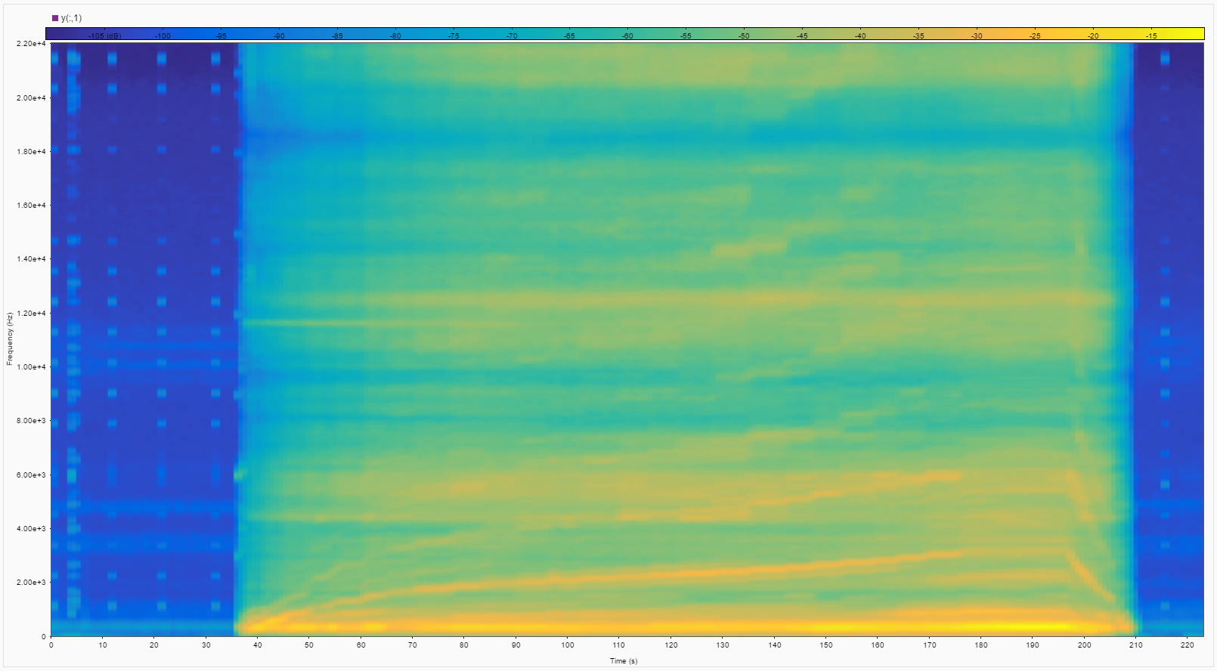

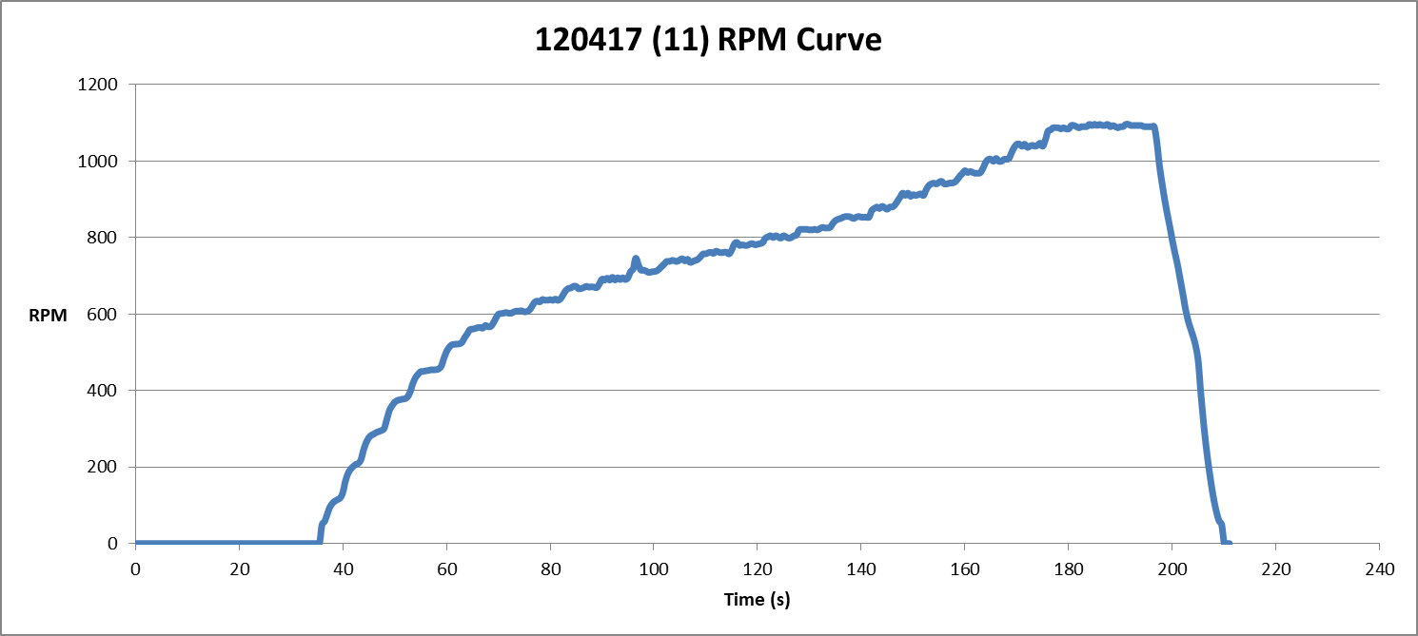

* Run 24: Pitch Angle 15ᵒ, With Gel Mass, Without Vibration Isolating Stand

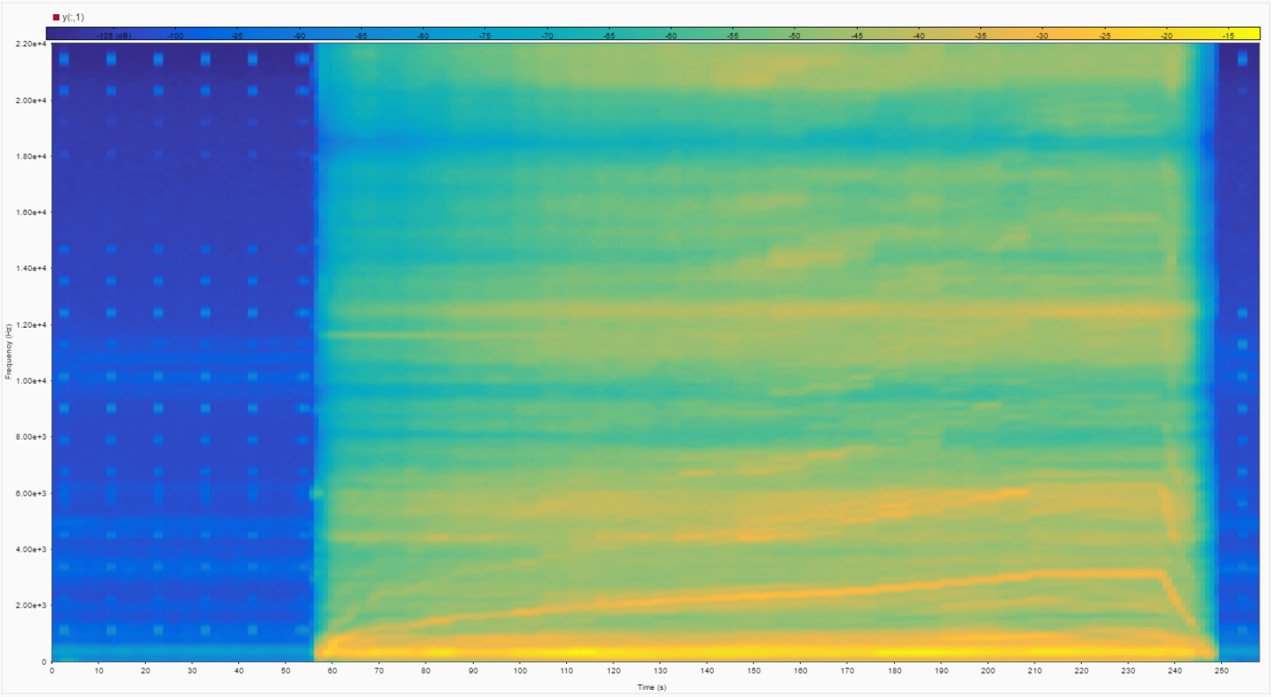

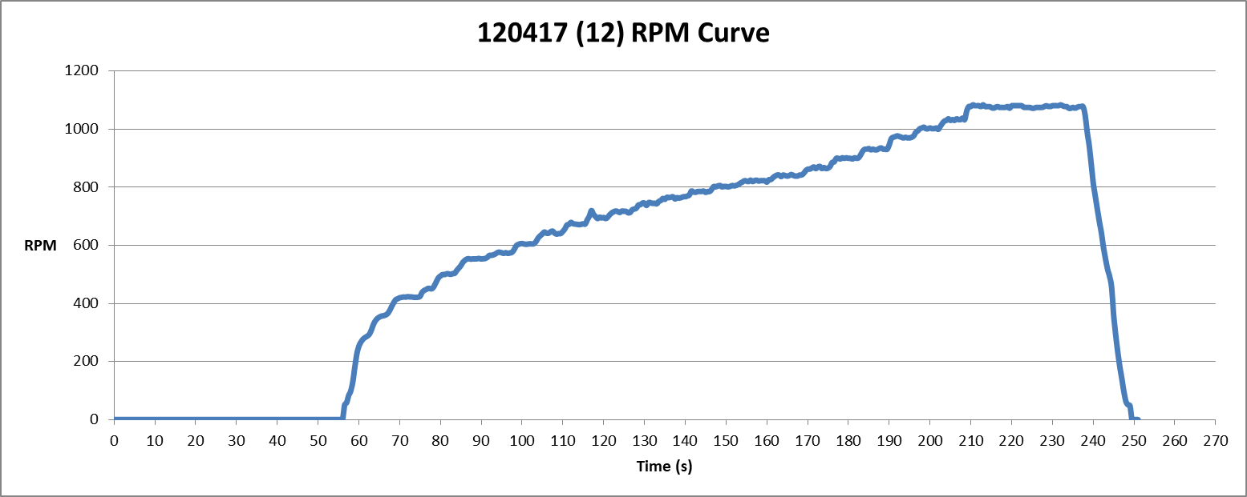

* Run 25: Pitch Angle 14.5ᵒ, With Gel Mass, Without Vibration Isolating Stand

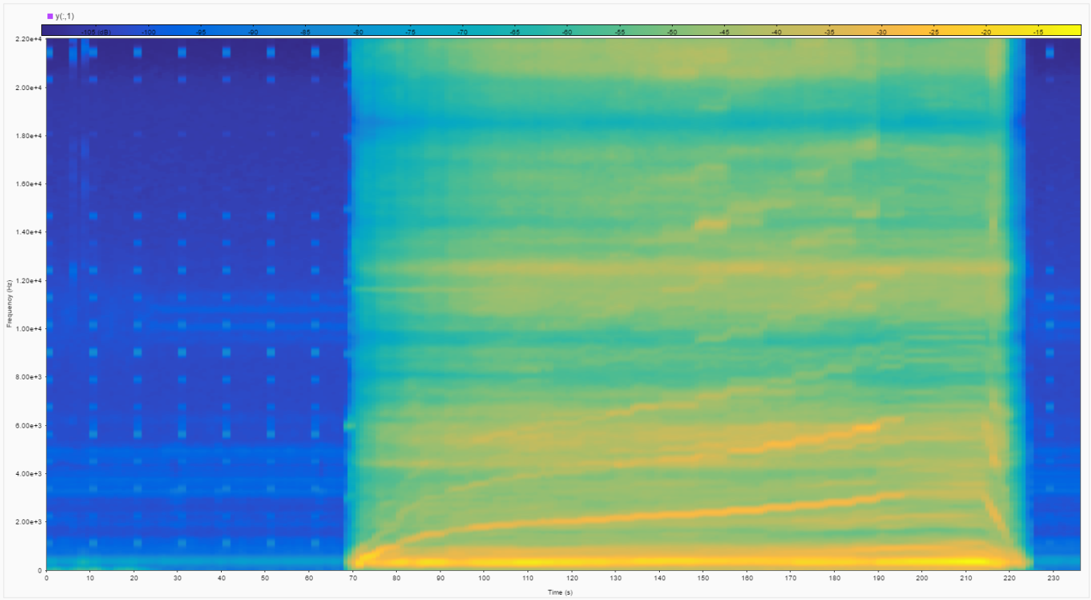

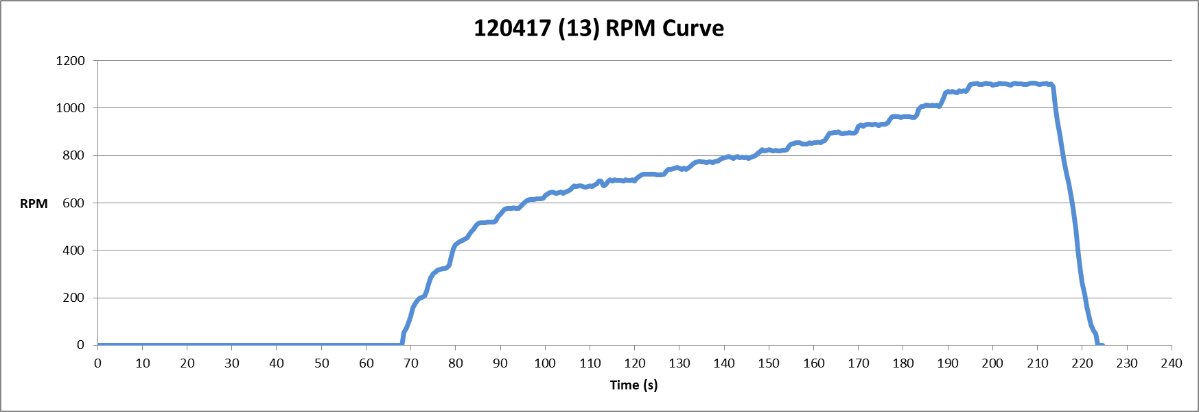

* Run 26: Pitch Angle 14.5ᵒ, With Gel Mass, Without Vibration Isolating Stand

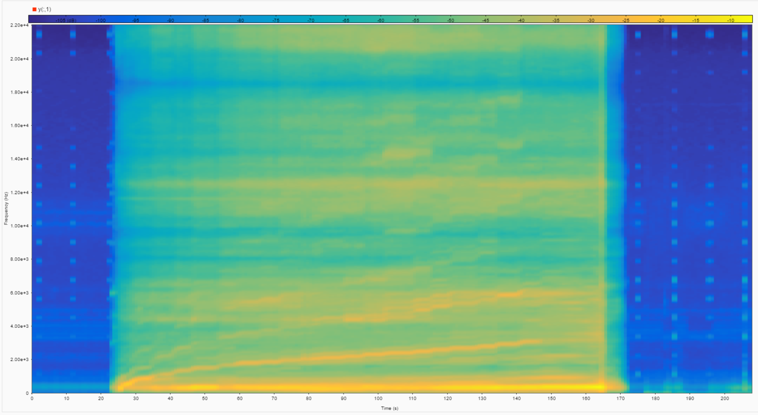

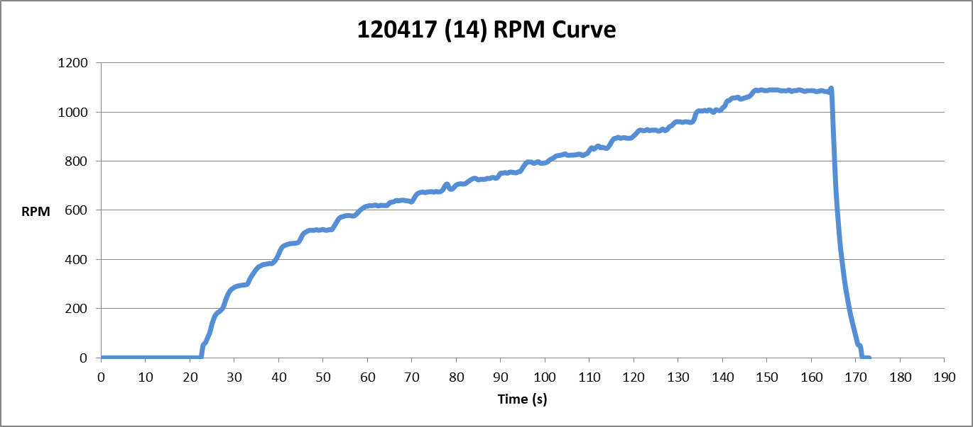

**Calculating the Natural Frequency of The Test Stand**

* Trial 1

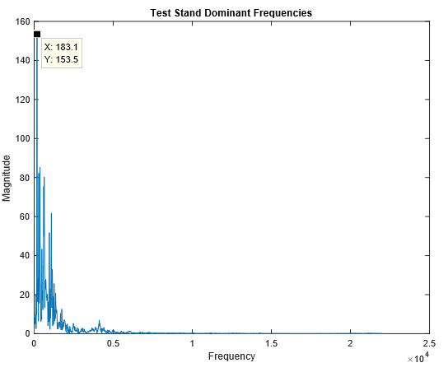

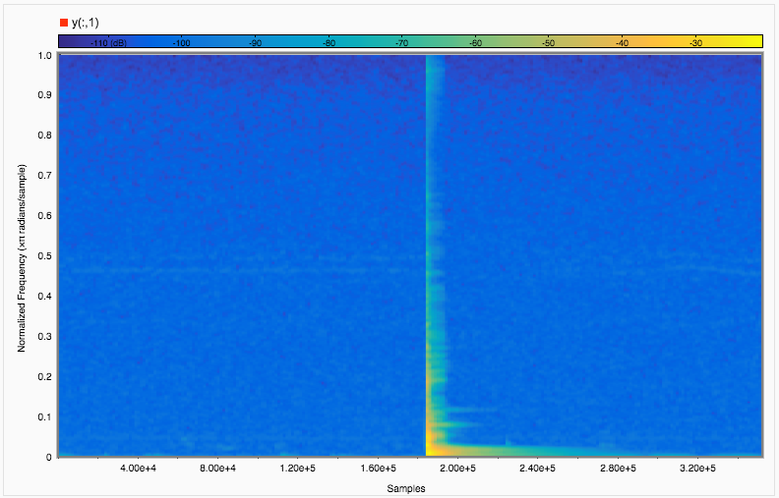

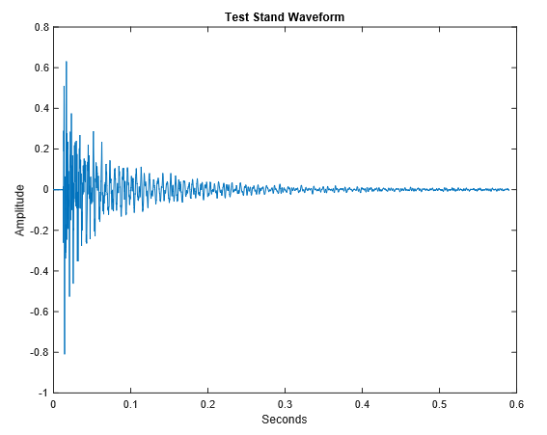

* Trial 2

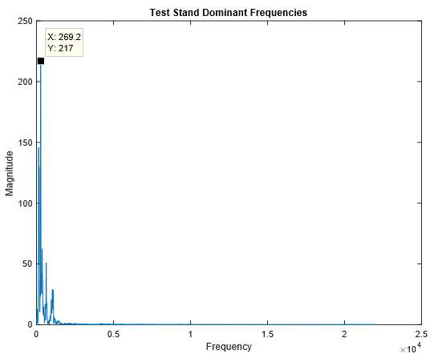

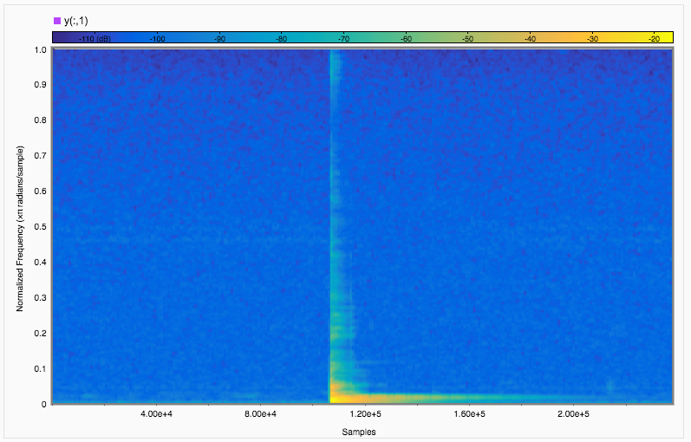

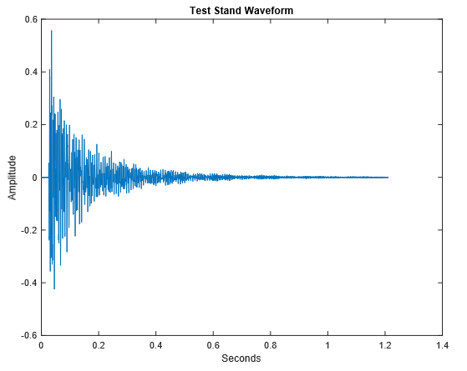

* Trial 3

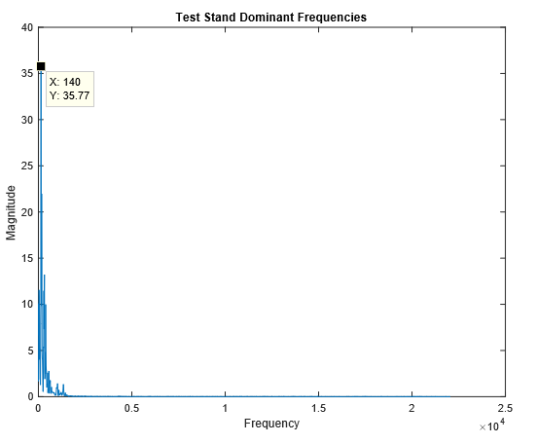

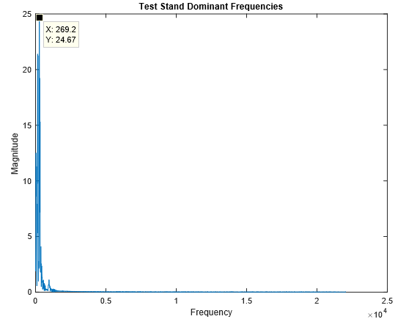

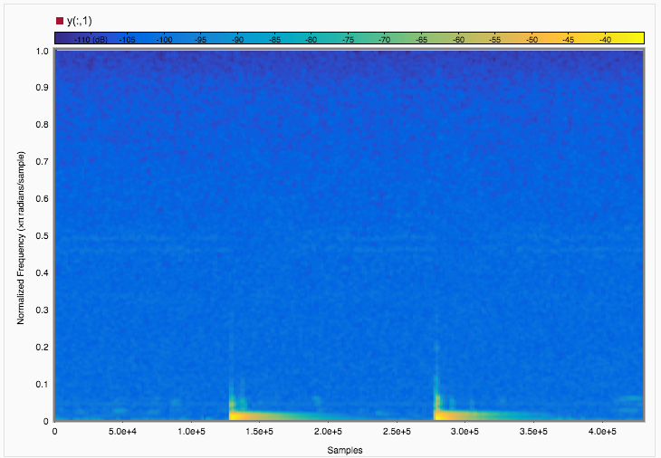

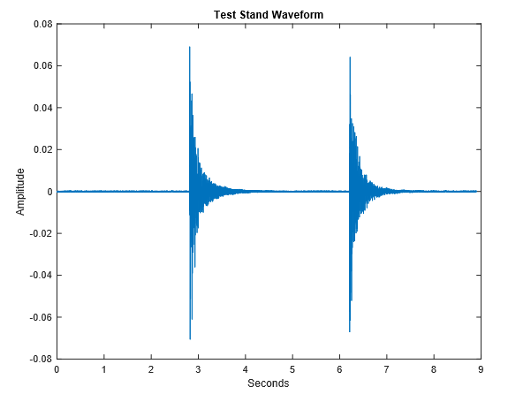

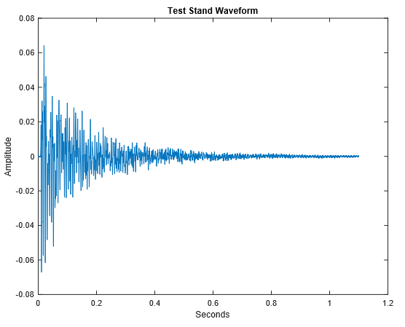

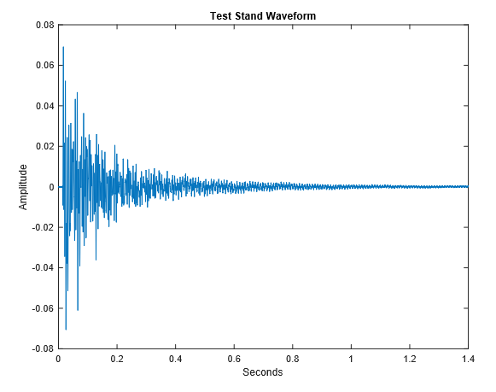

* Trial 4

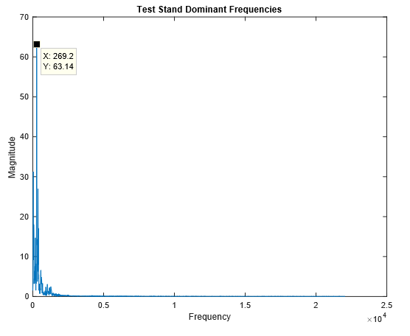

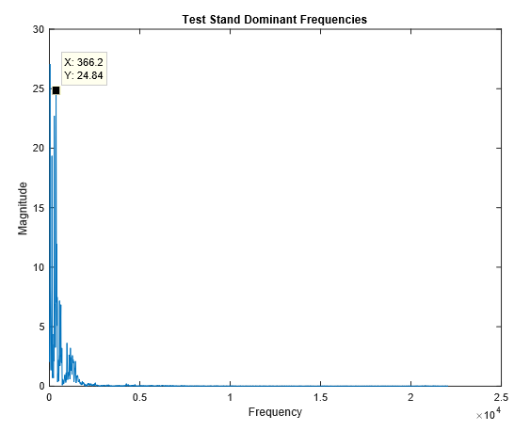

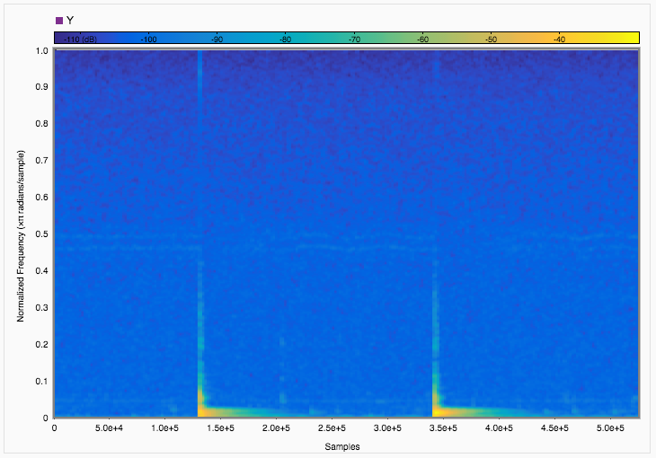

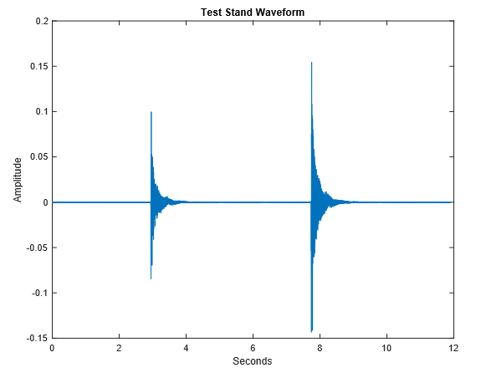

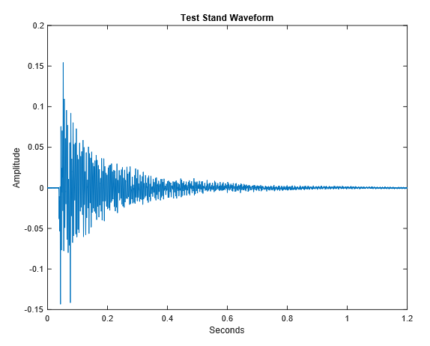

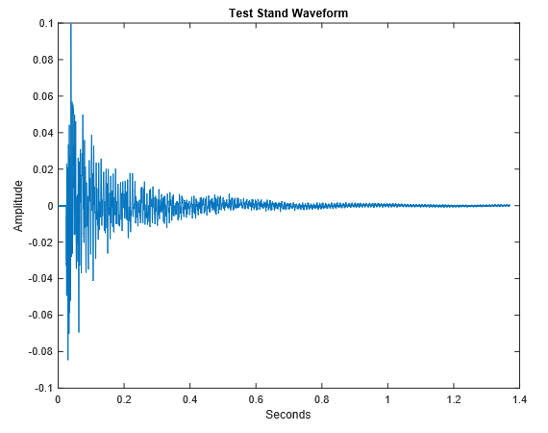

**Statistical Analysis**

**General Linear Model: RMS versus Stand, Gel, Pitch Angle**

Method

Factor coding (-1, 0, +1)

Factor Information

Factor Type Levels Values

Stand Fixed 2 0, 1

Gel Fixed 2 0, 1

Pitch Angle Fixed 7 9.0, 9.5, 12.0, 12.5, 14.0, 14.5, 15.0

Analysis of Variance

Source DF Adj SS Adj MS F-Value P-Value

Pitch Angle 6 0.025469 0.004245 2.26 0.042

Gel 1 0.004810 0.004810 2.57 0.112

Stand 1 0.008671 0.008671 4.62 0.034

Error 121 0.226855 0.001875

Lack-of-Fit 4 0.006484 0.001621 0.86 0.490

Pure Error 117 0.220371 0.001884

Total 129 0.288606

Model Summary

S R-sq R-sq(adj) R-sq(pred)

0.0432994 21.40% 16.20% 10.82%

Coefficients

Term Coef SE Coef T-Value P-Value VIF

Constant 0.11740 0.00752 15.60 0.000

Pitch Angle

9.0 -0.0198 0.0135 -1.46 0.147 1.45

9.5 -0.0115 0.0109 -1.05 0.294 1.22

12.0 0.0244 0.0135 1.80 0.075 1.45

12.5 -0.01179 0.00927 -1.27 0.206 1.23

14.0 -0.0183 0.0101 -1.82 0.072 1.45

14.5 0.01238 0.00775 1.60 0.113 1.14

Gel

0 -0.01133 0.00707 -1.60 0.112 1.42

Stand

0 0.01189 0.00553 2.15 0.034 1.51

Regression Equation

RMS = 0.11740 - 0.0198 Pitch Angle_9.0 - 0.0115 Pitch Angle_9.5 + 0.0244 Pitch Angle_12.0

- 0.01179 Pitch Angle_12.5 - 0.0183 Pitch Angle_14.0 + 0.01238 Pitch Angle_14.5

+ 0.0246 Pitch Angle_15.0 - 0.01133 Gel_0 + 0.01133 Gel_1 + 0.01189 Stand_0

- 0.01189 Stand_1

Fits and Diagnostics for Unusual Observations

Obs RMS Fit Resid Std Resid

8 0.2468 0.1650 0.0818 2.02 R

31 0.0002 0.0986 -0.0984 -2.33 R

32 0.0002 0.0986 -0.0984 -2.33 R

94 0.2072 0.1223 0.0849 2.03 R

110 0.2477 0.1530 0.0947 2.22 R

115 0.3220 0.1530 0.1690 3.96 R

130 0.2962 0.1530 0.1432 3.35 R

R Large residual